SERBIA FLOODS EMERGENCY AND RECOVERY PROJECT
(FERP)

Component 3
Abbreviated Resettlement Action Plan
(ARAP)

For Valjevo Flood Protection subproject



Republic of Serbia
Ministry of Agriculture, Forestry and Water Management
Directorate for Water
Project Implementation Unit

March 2019

CURRENCY EQUIVALENTS
(Exchange Rate Effective February 12, 2019)
Currency Unit = RSD
104,2 RSD = USD 1
118,0 RSD = EUR 1

ABREVIATIONS AND ACRONIMS
RS Republic of Serbia
BoE Beneficiary of Expropriation
CE Citizen Engagement
GC Grievance Committee
IFIs International Financial Institutions
OP Operational policy of the World Bank
PAP Project Affected Person
PIU Project Implementation Unit
FERP Serbia Floods Emergency and Recovery Project
RNA Recovery Needs Assessment
ARAP Abbreviated Resettlement Action Plan
RPF Resettlement Policy Framework
WB World Bank
OP 4.12 Operational Policy on Involuntary Resettlement
MAEP Ministry of Agriculture and Environmental Protection
MF Ministry of Finance
PWMC Public Water Management Company
RSD Serbian Dinar

LIST OF DEFINITIONS/GLOSSARY
COMPENSATION. Payment in cash or in kind for an asset or a resource that is acquired or affected by a project. Compensation will be paid before taking possession of the land and assets in all cases, including where this is not possible due to the absence of the owners. In the case of absence of owners, the money will be deposited to an escrow account for 3 years.
CUT-OFF DATE. Date of the Census i.e. July 19, 2018 shall serve as the cut-off date. Persons who encroach on the area after the cut-off date are not entitled to compensation or any other form of resettlement assistance. Similarly, fixed assets (such as built structures, crops, fruit trees, and woodlots) established after the cut-off date will not be compensated.
ECONOMIC DISPLACEMENT. Loss of income streams or means of livelihood, resulting from land acquisition or obstructed access to resources (land, water or forest) resulting from the construction or operation of a project or its associated facilities.
EXPROPRIATION. Means deprivation or limitation of ownership rights of property with a compensation pursuant to market value of that property.
INVOLUNTARY RESETTLEMENT. Resettlement is involuntary when land is acquired through the application of state powers. Actions may be taken without the displaced person’s informed consent or power of choice.
LIVELIHOOD RESTORATION. Measures that will be undertaken to assist physically and economically displaced PAPs to improve their livelihoods and standards of living or at least to restore them, in real terms, to pre-displacement levels or to levels prevailing prior to the beginning of project implementation, whichever is higher. Assistance must continue after displacement, for a transition period, based on a reasonable estimate of the time likely to be needed to restore their livelihood and standards of living.
MOVING ALLOWANCE. The moving allowance is a cash compensation for costs directly associated to moving/relocation of the household.
PAP. Project Affected Person is any person who, as a result of the implementation of a project, loses the right to own, use, or otherwise benefit from a built structure, land (residential, agricultural, or pasture), annual or perennial crops and trees, or any other fixed or moveable asset, either in full or in part, permanently or temporarily.
PHYSICAL DISPLACMENT. Loss of shelter or property caused by expropriation of land in connection with the project, which requires the physical shifting of a PAP from his/her pre-project place or residence, place for work or business premises.
REPLACEMENT COST. For agricultural land, replacement cost is the pre-project or pre-displacement, whichever is higher, market value of land of equal productive potential or use located in the vicinity of the affected land, plus the cost of preparing the land to levels similar to those of the affected land, plus the cost of any registration and transfer taxes. For land in urban areas, it is the pre-displacement market value of land of equal size and use, with similar or improved public infrastructure facilities and services and located in the vicinity of the affected land, plus the cost of any registration and transfer taxes. For houses and other structures, it is the market cost of the materials to build a replacement structure with an area and quality similar to or better than those of the affected structure, or to repair a partially affected structure, plus the cost of transporting building materials to the construction site, plus the cost of any labor and contractors' fees, plus the cost of any registration and transfer taxes. In determining the replacement cost, depreciation of the asset and the value of salvage materials are not taken into account, nor is the value of benefits to be derived from the project deducted from the valuation of an affected asset. It also includes costs for levelling or other preparation for new construction or use. Costs are calculated based on the time at which the asset is being replaced, if not, inflation is taken into account in calculating costs.
ABBREVIATED RESETTLEMENT ACTION PLAN (ARAP). The document specifying the procedures to be followed and the Actions to be taken to mitigate adverse effects, compensate losses, and provide development benefits to persons and communities affected by an investment project in cases when less than 200 persons are affected by the Project or the resettlement impacts are minor. The ARAP should be consistent with the principles and objectives of OP 4.12 and with the RPF.
MINOR RESETTLEMENT IMPACTS. To categorise resettlement as minor resettlement impacts all of the following conditions have to be met: met: all of the PAPs lose less than 10 percent of their land, regardless of the number of PAPs (b) the remainder of their land is economically viable; and (c) they have no need for physical relocation.
RESETTLEMENT POLICY FRAMEWORK (RPF). RPF is a Project level document meant to clarify resettlement principles, organizational arrangements, and design criteria to be applied to subprojects to be prepared during project implementation. It contains clear definitions of conditions under which the resettlement (for a specific project, a sector program or within a political entity like a state or a province) will be planned and implemented. It defines issues like entitlement, principles of compensation, grievance processes and other legal procedures. An RPF is required for projects with subprojects or multiple components that cannot be identified before project approval. The RPF should be consistent with the principles and objectives of OP 4.12.
STAKEHOLDERS. Any and all individuals, groups, organizations, and institutions interested in and potentially affected by a project or having the ability to influence a project.

Contents
EXECUTIVE SUMMARY - 8 -
Project Background - 8 -
Sub-Project activities - 8 -
Project implementation arrangements - 8 -
Sub-Project Impacts - 8 -
Status of Expropriation Process - 8 -
1. INTRODUCTION - 9 -
1.1 Project description - 9 -
1.2 Sub-Project Area Description and Context - 9 -
1.3 Sub-Project Objectives and Activities - 10 -
1.4 Scope and Purpose of Abbreviated Resettlement Action Plan - 12 -
1.5 Objectives and Principles of the Abbreviated Resettlement Action Plan and Land acquisition - 13 -
1.6 Study methodology - 13 -
1.7 Status of Expropriation Process at preparation of this ARAP - 14 -
2. LEGAL FRAMEWORK - 16 -
2.1 The National Land Policy - The Republic of Serbia Expropriation Law - 16 -
2.2 Public interest and purpose of expropriation - 17 -
2.3 Expropriation process - 17 -
2.4 Valuation - 17 -
2.5 Information and consultation requirements - 18 -
2. 6 Information of public importance - 18 -
2.7 Other Applicable Laws and Provisions - 19 -
3. THE WORLD BANK POLICY ON INVOLUNTARY RESETTLEMENT (OP/BP 4.12) - 19 -
3.1 Gap analysis between relevant national legislation and World Bank OP. 4.12 - 19 -
4. MINIMIZATION OF IMPACTS - 23 -
5. AFFECTED PEOPLE AND PROJECT IMPACTS - 23 -
5.1 Overview of Project Impacts - 23 -
5.2 Census/Inventory - 27 -
5.2 Socio-economic Survey - 27 -
5.4 Socio-economic assessment of the PAPs - 28 -
6. RESETTLEMENT COMPENSATION STRATEGIES - 31 -
6.1 Key Principles - 31 -
6.2 Cut-Off Date - 31 -
6.3 Eligibility - 32 -
6.4 Valuation - 33 -
6.5 Compensation for expropriated land - 33 -
7. GRIEVANCE MANAGEMENT & REDRESS - 34 -
7.1 Organizational Arrangements for Grievance Management - 34 -
7.2 Grievance Procedure - 34 -
8. Consultation and Participation - 36 -
9. Institutional arrangement and Implementation Team - 37 -
9.1 Responsibility for Implementation - 37 -
9.2 Institutional Capacities - 37 -
10. Implementation Schedule - 38 -
10.1 Monitoring, Evaluation and Reporting - 39 -
10.2 Completion Report - 40 -
11. Costs and Budget - 40 -
Annex 1 – Invitation to Public Consultation on ARAP Draft - 42 -
Annex 2 – Socio-economic Survey Questionnaire - 43 -
Annex 3 – Summary of Socio-economic Data for those expropriated - 47 -
Annex 4 – Grievance Commission brochure - 49 -
Annex 5 – Grievance registration Form - 51 -
Annex 6- Social screening check list - 53 -
Annex 7– Individual invitation to Public consultation on draft ARAP - 55 -
Annex 8 - Constitution of Grievance Commission (Original in Serbian) - 56 -

List of tables:
Table 1 Gap Analysis - 20 -
Table 2: Overview of affected land plots by type of ownership and area - 24 -
Table 3: Data on PAPs affected by expropriation - 24 -
Table 4: Data on PAPs affected by sovereignty to be exercised over occupied public land. - 25 -
Table 5: Overview of Affected Land Plots disaggregated by gender under both impacts - 25 -
Table 6: Overview on land size patterns - 25 -
Table 7 Overview of type of land type patterns - 25 -
Table 8: Entitlement matrix for impacts identified - 31 -
Table 9: Organizational Responsibilities and Arrangements - 36 -
Table 10: Tentative Implementation Schedule for ARAP Valjevo - 37 -
Table 11: Assessment of Budget to be paid for Expropriation - 40 -

List of figures:
Figure 1 Valjevo during the 2014 floods - 13 -
Figure 2 Project location, Valjevo, work zone marked on Raska River, Dezevska River and Banjska River in blue - 14 -
Figure 3 Impact on the structure partially occupying public land - 27 -
Figure 4: Demographic features of households - 30 -
Figure 5: Household income - 32 -
Figure 6: Employment status - 32 -
Figure 7: Organization of PIU - 42 -

EXECUTIVE SUMMARY

Project Background
During the third week of May 2014, exceptionally heavy rains fell on Serbia. This resulted in devastating floods causing significant economic hardship for much of the population in Serbia. The heavy rainfall with no precedent started in early/mid-May 2014 causing massive floods, destroying houses, bridges and sections of roads, resulting in the declaration of a national state of emergency on May 15, 2014 (pursuant to Article 32, Paragraph 3 of the Law on Emergency Situations, (Official Gazette of the Republic of Serbia, No. 111/2009, 92/2011 and 93/2012), across the country, which was in force until May 23rd.
The Government conducted a Recovery Needs Assessment (RNA) completed on July 10, 2014 with the objective of estimating disaster effects. The RNA was presented at a donor’s Conference convened in Brussels on July 16, 2014 in the aftermath of the natural disaster, revealing that the energy sector was the hardest hit and significant infrastructure damaged.
On October 9, 2014 the World Bank approved an Emergency Loan in the amount of $300 million to support the Government of Republic of Serbia to remedy existing damages and prevent future flooding. The Project will bring evident benefit by avoided damages of agriculture production, land, assets, households, business etc. The Loan has been restructured by Amendment to the Loan Agreement and Supplemental Letter confirmed by the Serbian counterpart on June 1, 2017. The Project is implemented by the Ministry of Agriculture, Forest and Water management namely it’s PIU.

Sub-Project activities
The flood protection works are executed across the country where the largest vulnerabilities were identified. Valjevo flood Protection sub-project will have civil works along the banks and within the basin of the Obnica River bed from km 1 + 250 to km 2 + 290 and reconstruction of the access bridge in the entrance zone to the correction facility KPZ “Valjevo”.

Project implementation arrangements
The Floods Emergency Recovery Project (FERP) is implemented by the Ministry of agriculture and environmental protection, Directorate for Water, namely by its PIU which completed the Irrigation and Drainage Rehabilitation Project (IDRP,P087964), another World Bank funded Project, which closed on March 31, 2013 .

Sub-Project Impacts
Valjevo Flood Protection sub-project requires land acquisition of 11 privately parcels of land owned by 13 private owners (originally there were 8 parcels, some of which were divided and sub parcels also affected), and administrative transfer of state-owned land in three other cases. The affected privately-owned land covers a total area of 3339 m². The smallest part of land to be acquired has an area of 20 m² whereas the largest is 1610 m² and the average area is 303,5 m2. As per categorization in the cadastre, the categories of land vary and consists mainly of meadows and gardens.
The expropriation process includes only acquisition of land, minor impacts to some fruit bearing trees and one wired fence without physical relocation of households or businesses.

Status of Expropriation Process
The Government of the Republic of Serbia on April 5, 2018 rendered the Decision on Public interest No 465-3059/2018. Pursuant to the Decision the official process commenced, instigated by the Public Defender’s office in Valjevo in October 2018 The Public Defender is the legal representative of the Beneficiary of expropriation i.e. city of Valjevo.
By the time this ARAP has been prepared the land acquisition process had been completed and all Project Affected Persons (PAPs) reached amicable settlement agreement on compensation and were compensated. The preparation of ARAP was delayed since the City administration experienced significant changes and the appointment of authorized representatives was also delayed which did not prevent the day-to day-administration to continue, but information on the specific activities conducted had only become available later. Furthermore, the socio-economic survey was only possible to be conducted with the support of the city administration whose appointment was delayed.
The average valuation provided by the Tax administration office for affected land is 1.372RSD/m2 or 11.62 EUR/m2 equivalent. The total amount offered to the affected owners is 4.586.110,00 RSD (38.864,33 EUR and 43.775.83 USD equivalent) and the compensation has been paid to all PAPS. Contingency fund for taxes and transaction cost for PAPs who opt to acquire replacement land will be available until project closing (November 2019). T More details on expropriation process and its status up to date are presented in Chapter 1.7 Status of Expropriation Process at preparation of this ARAP.

INTRODUCTION

1.1 Project description
Following devastating floods in 2014, the government of Serbia requested to address some of the country's most pressing needs in the wake of this disaster. Anan emergency Recovery Loan to address some of the country's most pressing rehabilitation and flood protection needs. The Loan was approved and signed on October 9, 2014 in the amount of $300 million. The Floods Emergency Recovery Project- is the second largest loan ever approved by the World Bank Group in Serbia. The aim of the proposed investments is to reduce imminent risk of recurring floods by restoring and/or improving the function of existing infrastructure. The objectives of FERP are to help restore power system capability to reliably meet domestic demand; (ii) protect livelihoods of farmers in flood affected areas; (iii) protect people and assets from floods; and (iv) improve the Borrower’s capacity to respond effectively to disasters. The Project includes 4 components (1) Energy Sector Support; (2) Agricultural Sector Support; (3) Flood Protection; and (4) Contingent Emergency Response. EUR 16.72 million have been assigned to Component 3: Flood Protection.
Prior to the floods in 2014, the Government of the Republic of Serbia based on climate behaviour and rainfall statistics assessed the need to protect Valjevo, among other locations, from any future floods. Based on repair/rehabilitation urgency and considering the extent of damage and risk of future impacts areas particularly vulnerable to floods were identified. Based on their vulnerability they have been chosen to be one of the sub-projects to be included in the Project’s Flood Protection Component (No 3). The sub-projects presented below were identified at appraisal stage or by the Decision of the Government and in agreement with the World Bank
- Flood Protection of Valjevo settlement,
- Flood Protection of Nis,
- Flood Protection of Aleksinac,
- Flood Protection of Novi Pazar,
- Flood Protection of Vršac,
- Sava River - Gomolava,
- Flood Protection of Smederevska Palanka settlement,
- Flood Protection of Negotin area
- Construction of flood protection system for Donji Ljubes settlement,
- Rehabilitation of Tamis dike,
- Erosion protection and rehabilitation works on left bank on the Sava River
- Rehabilitation of the left bank embankment on the Danube River on section B. Palanka town and Smederevo town

This ARAP is prepared for the Flood Protection of the city of Valjevo a sub-project which was added in mutual agreement between the World Bank and the Republic of Serbia, represented through the PIMO/ FERP PIU namely.

1.2 Sub-Project Area Description and Context
During the 2014 floods, the Obnica River and some of its tributaries caused severe floods, especially affecting Valjevo settlement and surrounding villages.
Valjevo is a city and the administrative centre of the Kolubara District in western Serbia. It is located in the valleys of the Jablanica, Obnica, Ljubostina, Gradac and Kolubara rivers. Also, the artificial lake Rovni is located 15 kilometres from the centre of Valjevo. The city is surrounded by Medvednik, Jablanik, Povlen, Maljen and Suvobor mountains; including Divčibare plateau of mountain Maljen. The total area of the City is 905 km² at average altitude of 185 meters, including over 70 settlements.
According to the last official census in 2011, the City of Valjevo has 90,312 inhabitants, 59,073 of whom are inhabitants of the urban Valjevo city area., Population density in the municipality is close to 100 inhabitants per square kilometre. Most of Valjevo’s population are Serbs (95%), followed by Romas, Montenegrins etc.
The following are some of the expected benefits from the proposed flood control in the context of implementation of the Project and the sub-project “Protection of Valjevo:”

- avoided damages of agriculture production on land likely to suffer frequent floods;
- avoided damages of assets (private houses; apartment houses; industrial facilities;
roads, electricity, schools, kindergartens, health facilities and other public buildings);
- avoided losses of business due to uninterrupted production, provision of services,
uninterrupted communications, trafic disruption, etc;
- avoided human health costs due to reduction of pollution in the water supply
systems, reduced water borne diseases, and reduced risks of human life losses;
- increased recreation benefits including potential for tourism development;
- Indirect economic development effects.

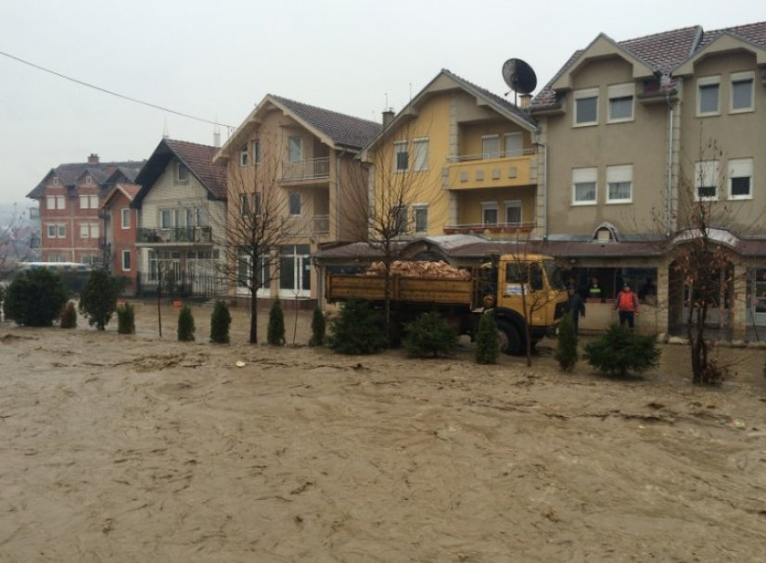
Figure 1 Valjevo during the 2014 floods
Given the nature of the works all land parcels are located on the very boundaries of the river bed. Since the floods are recurring events it has been identified that some of the land parcels have been impacted by the floods earlier and eroded into the river. The erosion rugged the river banks which directly influenced the design and technical solutions.
Targeted flood protection and drainage investments aim to reduce expected losses and generate substantial economic benefits justifying the investment costs. This includes a direct positive impact on the livelihoods of project beneficiaries, as losses – including public infrastructure, agricultural and livestock production, as well as family household assets - are significantly reduced with construction of flood protection infrastructure.

1.3 Sub-Project Objectives and Activities
Obnica is the river in Western Serbia that springs at the foot of the mountain Medvednik. It flows to the East, through of the city of Valjevo where confluence with the river Jablanica and Obnica together form Kolubara river which is the third largest river in Serbia after Danube and Sava. Obnica river is 25 km long, characterized with unevenness of flow, violent speeds and erosion processes in the period of high waters.
Floods that have taken place in May 2014 made a huge damage to the Obnica riverbed and nearby facilities. Significant damage has been made to three bridges in vicinity of KPZ Valjevo (correctional institutions for minors). Bridges lost functionality and traffic could not take place. After floods, bridge 1 is re-built and lot of extensive activities were undertaken with the aim of reconstructing existing and constructing new facilities in the zone of the KPZ Valjevo complex. In order to complete all construction activities, it is necessary to take appropriate measures and works in order to prevent a re-flooding scenario.
The subject sub-project of flood protection in the area of Valjevo includes regulation of the Obnica river bed from km 1+250 to km 2+290 and reconstruction of the access bridge in the entrance zone to the KPZ Valjevo (Bridge 2 at km 1+491).
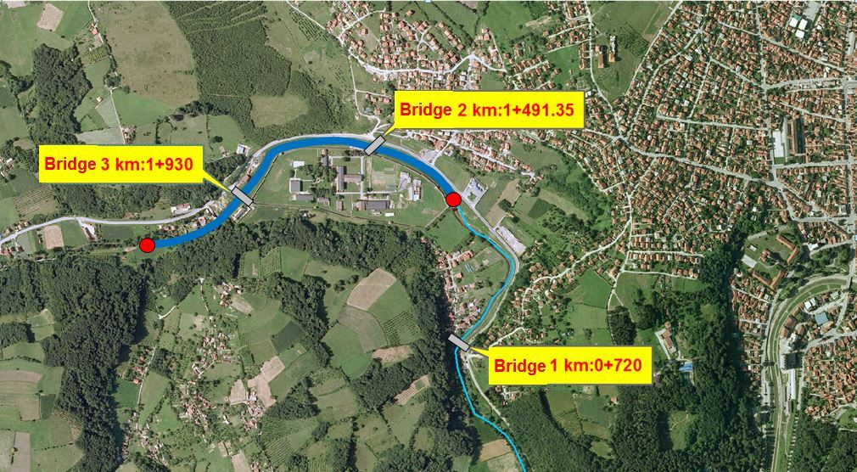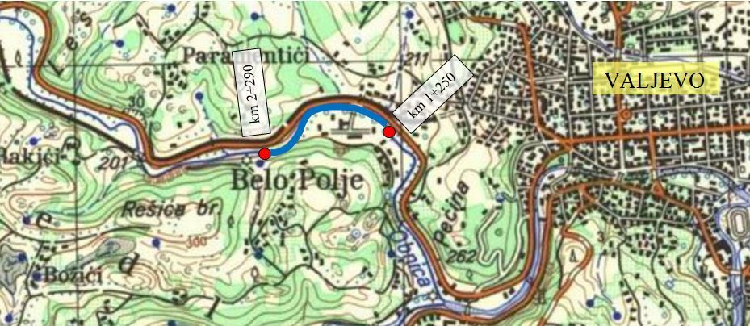

Figure 2 Project location, Valjevo, work zone marked in blue on both pictures
The works are executed mainly within the right of way, but nevertheless requiring land acquisition and divided into three parts:
- First major part of proposed project is related to Obnica river bed regulation and other works in the zone of the river basin, in order to increase the level of flood protection from km1+250 to km2+290;
- Second major part of proposed project is related to the construction of a new bridge 2 in the entrance zone of the correction facility KPZ Valjevo. Route of the mobile flood protection system is next to the future reinforced concrete structure – river bed area in the bridge zone. The total length corresponds to the length of the plateau on section 2 and it is 80 m (from km 1+480 to km 1+560);
- The third part envisages procurement of mobile flood protection systems and drainage works within and adjacent to the entrance zone of KPZ Valjevo.
The subject regulation also envisages a technical solution for the protection of the settlement located on the left bank of the Obnica river, upstream of the prison complex that is flooded due to unfavourable hydraulic conditions. The estimated length of the defence line in the zone of this settlement is 300m.
Works within the scope of this project will contribute to achieving sufficient river flow capacity in order to ensure the stability of the M4 Valjevo-Loznica road from future floods.
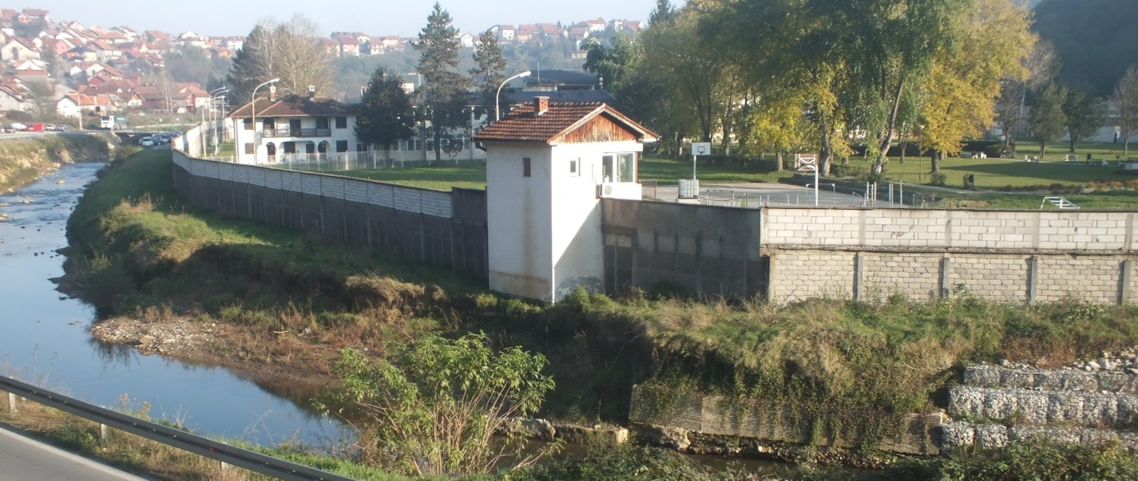
Figure 3: KPZ Valjevo and downstream view of Obnica river
The focus is embankments of the river and four different types of works are proposed:
- Construction of Flood Protection structures,
- Reconstruction of the weak points on the embankment,
- Upgrading sections of embankment from the 1:25 year flood to the 1:100-year flood, and
- Bank armouring in locations where erosion of the riverbank may undercut the embankment.

1.4 Scope and Purpose of Abbreviated Resettlement Action Plan
An Abbreviated Resettlement Action Plan is adequate for the Valjevo sub-project as less than 200 PAPs are affected and no physical resettlement is anticipated. Impact include administrative transfer of minor area of state-owned land in cases of KPZ Valjevo (state correctional institution), two land parcels co-owned by the City of Valjevo and the Republic of Serbia, used as part of the road, but with no impacts on any of buildings or constructed facilities or infrastructure. Compensation for acquisition of affected land and minor assets (perennial plants) has been paid to all PAPs. Civil works are anticipated to start in April 2019, but not until this ARAP is disclosed following the public consultations. Detailed description of impact is given in chapter 5. AFFECTED PEOPLE AND PROJECT IMPACTS .
In accordance with the Loan Agreement, a Resettlement Policy Framework for the Project was prepared, approved by the World Bank and relevant Serbian authorities and publicly disclosed in 2015 and is the guiding document for preparation of this ARAP.
The scope of work undertaken during the ARAP preparation included:
- Screening of project area;
- Survey of projected affected area, land and property thereon;
- Walk through the project area as field verification of location of land required, use of land required; presence of public or community infrastructure, number of affected persons;
- Census of the PAPs including persons and their land, assets and property thereon;
- Socioeconomic assessment of the PAPs;
- Identification of land, assets and properties likely to be affected;
- Analysis of valuation of the land and assets and property thereon to be expropriated;
- Consultations with Project Affected Persons (PAPs);
- Analysis of the legal framework;
- Analysis of institutional framework covering the identification of agencies responsible for
establishment of adequate Grievance mechanism; and
- Analysis of negotiated procedures, including offers made and considered by PAPs. a

1.5 Objectives and Principles of the Abbreviated Resettlement Action Plan and Land acquisition

This ARAP, and its detailed provision, is prepared according to the Laws and regulations of Republic of Serbia and the Resettlement Policy Framework prepared for this Project, which is consistent with the World Bank’s OP 4.12. The objective of this ARAP is to document the procedures followed and the actions taken to properly acquire land and compensate affected people by allowing and providing for adequate participation, consultation and full functioning of the grievance mechanism. Furthermore, the plan sets out actions on how to avoid and mitigate future impacts to land and provide prompt and effective compensation for residual impacts if any to those eligible. The objectives set shall be adhered to regardless of the scope and scale of impact.
The RPF for the FERP has outlined the key land acquisition and resettlement principles and objectives to be followed, the organizational arrangements and design criteria to be applied to subprojects to be prepared during Project implementation to ensure adequate management of land acquisition and access by sovereignty over occupied land required for the Project.
This ARAP specifies the following:
- Detailed procedures followed by Directorate for Water (DfW/PIU), City of Valjevo in respect to consultation and disclosure;
- Provide baseline census of affected persons and asset information;
- Describes specific compensation rates and standards;
- Describes consultations with affected people about acceptable alternatives and mitigation measures;
- Describes institutional responsibility for implementation and procedures for grievance redress;
- Provide a timetable and budget; Provide Implementation and monitoring arrangements.

The RPF and subsequently this ARAP is in line with the local legislation and OP 4.12. In case of discrepancy between local legislation and OP 4.12, the more stringent requirements will prevail. The preparation of this document has been guided by the WB Involuntary Resettlement Sourcebook: Planning and Implementation in Development Projects (2004), the Social Framework for Projects and good practice cases as well, but application of individual measures have been chosen based on consultation with PAPs to reflect the project specific needs.
This ARAP is tailored to cover identified direct economic and social impacts that both result from Bank assisted investment projects and are caused by:
- the involuntary taking of land resulting in loss of assets or access to assets.

1.6 Study methodology
The preparation of this ARAP was through a combination of desk and field study. The desk study involved review of project documentation including maps for the project sites, cadastral records, municipal database on PAPs and their assets, expropriation records, compensation offers and preliminary technical designs. The desk study was supplemented with surveying of the project sites to establish the exact impact of the proposed subprojects in terms of required land and affected property to create an inventory of PAPs and land. The field survey consisted of conducting household census of identified PAPs; conducting social assessment of the subproject sites along the corridor of impact along the River of Obnica, socioeconomic study of the PAPs as well as census and measurement of their land. The Census was prepared on the basis of data available through the Cadastral Register and the database of the City of Valjevo and individual interviews. Secondary data were used in addition to generated primary data obtained through the PAPs and interviews with government officials and non-government officials about PAPs and their assets. During analysis and interpretation of the gathered data equal weight was given to quantitative and qualitative aspects so that it reflects a balanced reality of the current situation of the PAPs. The data generated shall serve as baseline conditions against which the living standards shall be compared to during the follow up survey in the Completion Report.
The census of people affected by the project is a key initial stage in the preparation of the ARAP. The Project demographic data can serve four important and interrelated functions:
- Enumerating and collecting basic information on the affected population,
- Registering the affected population by residence,
- Establishing a list of persons eligible to receive entitlements before the properly announced moratorium or cut-off date that counters opportunistic claims from those moving into the Project Area solely in anticipation of benefits,
- Laying a framework for subsequent socio-economic research needed.

1.7 Status of Expropriation Process at preparation of this ARAP
1.7.1 Commencement of expropriation
The expropriation commenced following the declaration of the Public interest on April 5,2018.
1.7.2 Information on expropriation
After instigation of the expropriation, all individuals eligible to receive compensation as defined under 6.3 Eligibility have been individually invited during July 2018 to the Property department of Valjevo. During the individual hearings, detailed information on the proposed expropriation, the process to be followed and principles applicable has then been explained.
Invited were all individuals identified in the inventory list provided by the Cadastral office and enumerated in the detailed design for expropriation as well as those persons claiming they have the right of inheritance even if the succession procedure is not completed or formal transfer of rights in the Cadastre has occurred.
In order to facilitate legal successors of deceased owners to be recognized for entitlements without the delay of having to finalize the inheritance process the City of Valjevo has passed a decision authorizing the Public Defender and the Property department to recognize such persons as de facto owners and therefore PAPs with the right to claim and receive entitlements.
During this first consultation, maps with delineation of the Project were shown. It has been explained that the alignment of the Project is set following the footprint of the river, but that mitigation measures have been applied to avoid severe impacts.
All 13 PAPs (either personally or through legal representatives) signed off to the delineation of the Project thus to the area of land impacted and the expropriation itself.
1.7.3 Cut-off date
Following an individual invitation, during the July 2018 all PAPs were informed that a the Project will have an eligibility cut-off date, meaning that persons who encroach on the project area, or commence activities in construction, planting trees, crops, and any other fixed assets established after the cut-off date shall not be compensated and that the date of the Census i.e. July 19, 2018 shall serve as the cut-off date. At the individual consultations persons to be affected were informed that this meeting serves as a census and that the socio-economic survey shall be conducted to create a socio-economic baseline of each household against which the project impacts shall be measured. Posters with information about the cut-off date were posted at the City of Valjevo Notice Boards in July 2018.
1.7.34 Social survey
During December 2018 and February 2019, a Socio-economic survey was conducted with support of the City of Valjevo.
1.7.5 Asset screening
After the expropriation proposal was submitted to the Property department of Valjevo with supporting documentation, and first information disseminated, individual invitations to hearings on expropriation were sent to every PAP. The invitation specified the purpose, time and date of hearing proposed and provided the PAPs with a list of documents to be made available for presentation and discussion at the agreed time. At the individual hearings that took place in July .2018, PAPs and the City of Valjevo jointly signed off to the inventory of land plots, identified owner and confirmed that besides land, a limited number of assets attached to the land are affected in the form of trees and fruit bearing trees affixed to the land were identified. The land is near the river, and prone to erosions and under eminent flood risk wherefore the PAPs do not cultivate land adjacent to the river. The land is registered in the cadastre as pasture and gardens (grass and flowers), and none of the parcels were registered as agricultural land. The affected land is not cultivated. It At the time of asset screening, claims recognized or recognizable under the Law in respect to inheritance rights were submitted. The PAPs have been assisted with free legal aid by the Public Defender’s office. All categories of Project Affected Persons were individually consulted including the Project Affected Person with claims recognizable under the Serbian law.
1.7.6 Decision on expropriation
In the next step the Expropriation decisions were issued.
1.7.7 Valuation
Sufficient time was provided for appeal but none of the PAPs appealed to the decisions on expropriation. The decision became legally binding within 15 days of being served to every PAP individually. At this stage, national grievance bodies were available.
Following the legal validity of the decisions, the City of Valjevo submitted a request to the Tax administration office as the competent authority (in accordance with Article 42 Law on expropriation) to assess the value of land. The request was submitted for every case individually. The Tax administration has provided the valuation for all plots.
The Tax administration sent its valuation on August 2,2018. which was then distributed to the PAPs for consideration. Adequate period of time of minimum 15 days was given to allow due consideration of the offer given and registering any formal disagreement with the offer. During December 2018 all PAPs were invited to state their position on the offered compensation. The process ended by all PAPs accepting the offer and signing negotiated settlement agreements on December 18, 2018. The Project specific Grievance commission was not yet in place at the time due to the Administrative changes within the City Administration, which prevented GRM members to be identified by the Administration. However as per Law on Expropriation, a valuation specific complaints mechanism within the Tax administration office was available to PAPs, and the GRM was established on December 25, 2018 still allowing PAPs to access the panel, prior to payment of compensation. During signing of the compensation agreements on December 18, 2018 PAPs were informed that the GRM will be formally established by the end of the year at the latest, but that any grievance related to the expropriation process, valuation or compensation can be taken immediately as a note and be brought formally to the attention of the GRM later once established. All compensations were paid by end of January 2019. At the time of this writing, no grievances have been registered nor have any been taken during signing of the agreements.
1.7.8 Methodology applied during valuation
The value of land for each affected category was determined based on the market value of land of equal productive potential or use located in the vicinity of the affected area by comparison of sales transaction in the recent past by applying corrective factors to arrive at actual market value.
The valuation was conducted without site visits but based on comparable market value determined in at least two final decision of the tax authority, issued in the procedure of determining the tax on transfer of absolute rights by comparison of the same or similar land on the market, in the same cadastral City or adjacent, of the same or similar quality (gardens (grass and flowers), pastures, etc.). The comparable sales transaction considered are the one closest to the date when the valuation is conducted. Estimated value of the land has been increased by using the calibration factors depending on location, proximity to roads, provided infrastructure, proximity to populated areas, and registration fees if any. The average land valuation provided by the Tax administration office 1.372RSD/m2 or 11.62 EUR/m2. The valuation of land was conducted on a case-by-case basis.
1.7.9 Taxes and Fees
Under the Law on VAT (“Official Gazette of RS” No. 84/2004, 86/2004 - corrected 61/2005, 61/2007, 93/2012, 108/2013, 6/2014 – RSD amount adjusted. 68/2014 – other law, 142/2014, 5/2015 RSD amount adjusted, 83/2015 i 5/2016 – RSD amount adjusted….4/2019) the transaction of land by virtue of expropriation for flood emergency works is exempt from payment of VAT. These taxes have therefore not been included in the valuation.
Registration fee in the cadastre for transfer of property rights is born by the Beneficiary of Expropriation in accordance with the Law on State Cadastre (Official Gazette RS", No. 72/2009, 18/2010, 65/2013, 15/2015 – decision of Constitutional Court -S i 96/2015). These fees have therefore not been included under the valuation.
The only administrative fee that could be imposed to PAPs is the registration fee in case they would opt to buy new land to replace the expropriated land. So far PAPs did not declare their intent to buy replacement land. However, a corrective factor in form of a contingency of 10.000,00 RSD (84,74 EUR) per PAPs as the average cost of registration fee, has been applied. If at any time until Project completion but not later than November 2019 (project closure), PAPs declare their intent to buy replacement land the Beneficiary of Expropriation shall top up the compensation with the above said contingency amount. This shall be documented through minutes. The availability of the contingency fund shall be made available to the PAPs during the public consultation on the draft ARAP and should some PAPs not attend the consultation, individual notifications will be sent to them. The intent to acquire replacement land should be brought to the attention of the Property department of the City of Valjevo not later than November 2019.
1.7.10 Budget made available
At the planning stage, through the Budget for the fiscal year 2018 the City of Valjevo secured funds in the overall amount of 111 .400.000,00 RSD for land acquisition needs in general (944.000,00 EUR equivalent) into a Consolidated Treasury Account within the Budget appropriation). Most of these funds have now been spent on compensation. Under this account, earmarked payments could only be spent towards the designed purpose and is considered eligible expenditure under National Law on Budget and the Budget system (Official Gazette of RS No. 54/2009, 73/2010, 101/2010, 101/2011, 93/2012, 62/2013, 63/2013 - corr. 108/2013, 142/2014, 68/2015 – other and 103/2015, 99/2016, 113/2017 i 95/2018). Local self-governments are not allowed to open escrow or similar accounts with commercial Banks. For them a Consolidated Treasury Account is opened in the name of the local authority and operated by the Treasury (Bullet 39 of the Law – definitions). Any expenditure is appropriated by the Assembly of the local Government, by law on the Budget of the Republic of Serbia or the decision on the budget. Only by such appropriation is the Local Government authorized to spend public funds up to a specified amount and the for certain purposes (Bullet 31 definitions). Payments from the Consolidated Treasury Account for the implementation of any obligations of other public funds beneficiaries that are included in the consolidated treasury account system will not be made if the appropriation and budget has not been approved in the manner prescribed by law or act of the Assembly and local government and if the plan is not submitted to the Administration for Treasury for review and audit (Article 58- Payments from the Budget).
From these proceeds, secured through the Budget, payment to all PAPs has been made in the total amount of 4.561.441,00 RSD for land (equivalent of 38,656.28 EUR and 43,775.83 USD) and 57.171,00 RSD for crops and assets affixed to the land (equivalent of 484,5 EUR and 548,66 USD).

2. LEGAL FRAMEWORK

2.1 The National Land Policy - The Republic of Serbia Expropriation Law

The Republic of Serbia Expropriation Law (passed in 1995 and enacted on January 1, 1996, amended in March 2001, amended again on March 19, 2009, 2013 by the Constitutional Court ruling and in 2016 by the Authentic interpretation) guides expropriation and serves as a general framework for expropriation in the Republic of Serbia. The law also enshrines the principle of compensation at market value.
The most important features of the Law on Expropriation are:
It is intended to ensure simple, efficient process, reducing as far as possible the need for a lengthy judicial process to facilitate necessary expropriation. Under normal circumstances, the entire process of acquisition can be completed within six months;
The fair value of the land affected by a particular scheme, or project, is determined by the Tax Administration, on behalf of the “Beneficiary of Expropriation”. The value is assessed on the basis of current market price;
In the case of privately-owned agricultural land, if comparable land of the same type and quality, or the appropriate value, in the same area or vicinity (Article 15 of the Expropriation Law) can be identified, it is offered to the project affected person with formal title;
- The comparability of land is determined on the basis of an assessment of the available public land, by an accredited expert hired either by the Beneficiary of Expropriation, or the Ministry of Agriculture and Environmental Protection (MAEP);
- In case of disagreement on the comparability of the land offered, a different accredited expert would be hired by the local municipality to determine the comparability of the land offered;
- Further disagreement would result in the project affected person resorting to the judicial process, where a decision would be made on the comparability of the land, or the payment of the assessed fair value in monetary terms;
- If the Project affected person does not opt for land-for-land compensation s/he is offered cash;
- Where comparable land cannot be identified, the project-affected person with legal title is offered the assessed fair value as determined by the Tax Administration. If the project affected person wishes to challenge the assessment of “fair value” they can resort to the judicial process;
- For the project affected person, without formal title, there is no provision to pay compensation currently under the Law on Expropriation;
- In addition, after the passage of the Law on Planning and Construction (passed in 2009 and amended in 2011), it is a criminal offense to construct any structure without a building permit on either public or private land; and
- In the case of a project-affected person, with a formal title, who has constructed a permanent structure, without a formal building permit, compensation can be paid, if decided by a Court, under the Law on Fundamentals of Property Relations (1980, applicable from 1st September 1980, amended 1990, 1996 and 2005) in terms of the investment made – as determined by an accredited Expert to assess the value of the materials used.

2.2 Public interest and purpose of expropriation

Property can only be expropriated upon the establishment of public interest for projects that bring greater benefit for the public (Law on Expropriation, Art. 1).
Expropriation may be carried out for the needs of Republic of Serbia, cities, municipalities, public enterprises and public institutions, unless otherwise provided by the Law.
The Law on Expropriation requires the Beneficiary of Expropriation to justify the need for expropriation and to demonstrate that the scheme cannot occur without the proposed expropriation. The declaration of public interest/use is a special procedure, which precedes and enables any property acquisition and expropriation.
In case of expropriation for the Valjevo sub-project, the public interest has been established by the Governments decision 05 No. 465-3059/2018 dated April 5, 2018. The Decision is presented in Annex 9.

2.3 Expropriation process

A condition to start expropriation is the existence of evidence that the required funds have been secured and made available. It is necessary for the Beneficiary of Expropriation arranging a Bank Guarantee with a Commercial Bank for the assessed fair value or in case of Local Governments is the Beneficiary of expropriation adequate appropriations within the Budget are made (Art. 24).
The procedure for expropriation starts with a proposal for expropriation, submitted by the Expropriation Beneficiary to the relevant Municipality (“the expropriation authority”). A concrete expropriation proposal is prepared for each project-affected person that contains the amount of land involved, the assessment of fair value for any immovable property, the justification of the need for the specific expropriation, together with the confirmation that the scheme is included in the relevant regional and/or spatial plan.
Once the proposal has been submitted with supporting documentation individual invitations to hearings on expropriation are sent to every PAP. The invitation specifies the purpose, time and date of hearing proposed and provides the PAPs with a list of documents to be made available for presentation and discussion at the agreed time.
After the hearing with the individual PAP has been finalized an Expropriation decision is issued.
All the steps above were completed in the current sub-project expropriation process.

2.4 Valuation

At the valuation stage, the Beneficiary of Expropriation contacted the Taxation Administration for the assessment of fair value for all land.
In the event that the PAPs disagreed with the offered compensation in either form, they could have resorted to the judicial process, and the Beneficiary of Expropriation could have requested the Ministry of Finance, on an exceptional basis, to allow access to the site with assistance (Article 35). Such a decision would have been issued on a case to case basis assessing all relevant facts of the individual case. Based on the objectives of the Project, works to be executed are considered as urgent and access to site could be allowed. So far, no such claim has been made by the Beneficiary of expropriation.
Once the Expropriation Decision had been issued, it became legally binding and could not have been disputed by legal remedies. With issuance of Expropriation Decision, the negotiations on the compensation were ready to commence. The Agreement on compensation included the timing and rate at which cash compensation would be paid (Art. 26). If no agreement on compensation would have had been reached within 2 months of the validity of the Decision on Expropriation (or less if the Municipal Administration decides as such), the Municipal Administration would have submitted the valid Decision together with other relevant documents to the competent Court, for the purpose of determining the compensation. The competent court ex officio would have had decided in non-contentious proceedings on the amount of compensation for the expropriated property. However, in this case, all compensations agreements were amicably established.

2.5 Information and consultation requirements

The Law on expropriation does not require per se public dissemination of information on the area delineated, and systematic and continuous dissemination. Nevertheless, it requires public disclosure of the determination of Public interest and the Municipal authority to invite individually every affected person with formal legal rights to a meeting to present any facts which may be relevant for expropriation. It additionally requires timely dissemination and information of every decision within the process flowchart. This dissemination has statutory limits wherever a legal remedy is provided.

2. 6 Information of public importance

Information of public importance is information held by a public authority body, created during or relating to the operation of a public authority body, which is contained in a document and concerns anything the public has a justified interest to know. The Law on information of public importance (Official Gazette RS", br. 120/2004, 54/2007, 104/2009 i 36/2010) requires any document publicly disclosed to have integrated guidance on how to access information of public importance.
This subject is governed by the Law on Free Access to Information of Public Importance shall govern the rights of access to information of public importance held by public authorities, with a view to exercising and protecting the public interest to know and attaining a free democratic order and an open society.
By virtue of this Law access to information shall be granted to all stakeholders, including every natural person or legal entity upon written request unless otherwise regulated by the Law. Within 15 days of receipt of a request at the latest, the authority shall inform the applicant whether the requested information is held, and grant him/her access to the document containing the requested information or issue or send to the applicant a copy of the document, as the case may be. Annex 2 provides a template for access to information.

2.7 Other Applicable Laws and Provisions

Besides the Law on Expropriation, the following comprise the list of legal documents, policies and regulatory acts and frameworks dealing with expropriation and resettlement and other social impacts associated with flood protection works, representing basis of this ARAP:
- Law on Fundamentals of Property Relations (adopted in 1980, amended 1990, 1996 and 2005)
- Law of Planning and Construction (adopted and revised in 2009, and amended in 2011, 2013,2014 and 2018)
- Law on State Cadastre (adopted in 2009, amended in 2010 and 2018)
- Law on Spatial Planning of the Republic of Serbia from 2010 to 2020 (adopted in 2010)
- Law on waters (adopted in 2010 amended in 2012, 2016 and 2018)
- The Law on Elimination of the Consequences of Floods in Serbia (adopted in 2014 amended in 2015)

3. THE WORLD BANK POLICY ON INVOLUNTARY RESETTLEMENT (OP/BP 4.12)

All WB financed projects involving involuntary resettlement are subject to OP 4.12. The policy describes the procedures and instruments for eliminating negative economic, social and environmental issues that may arise OP 4.12 is triggered not only in cases of physical relocation, but any loss of land resulting in relocation or loss of shelter, loss of assets or access to assets and loss of income sources and means of livelihood.
The overall objectives of OP 4.12 are the following:
- (a) Involuntary resettlement should be avoided where feasible, or minimized, exploring all viable alternative project designs.

- (b) Where it is not feasible to avoid resettlement, resettlement activities should be conceived and executed as sustainable development programs, providing sufficient investment resources to enable the persons displaced by the project to share in project benefits. Displaced persons should be meaningfully consulted and should have opportunities to participate in planning and implementing resettlement programs.

- (c) Displaced persons should be assisted to improve their former livelihoods and standards of living or at least to restore them, in real terms, to pre-displacement levels or to levels prevailing prior to the beginning of project implementation, whichever is higher.
OP 4.12 distinguishes the following three categories of persons for eligibility for compensation and assistance:
a. Persons with formal rights to land (including customary and traditional rights recognized under the laws of the country).
b. Persons who do not have formal rights to land at the time the census begins but have a claim to such land and assets - provided that such claims are recognized under the country laws or become recognized through a process identified in the specific resettlement plans.
c. Persons without recognizable legal right or claim to the land they are occupying.

3.1 Gap analysis between relevant national legislation and World Bank OP. 4.12

The objectives of OP. 4.12 are clear in their aim to avoid involuntary resettlement caused by land acquisition measures wherever feasible and if not possible to apply such compensation principles for impacts on all PAPs and to restore their livelihoods at least to pre-project level. In general, the institutional framework for expropriation in Serbia is strong and broadly compatible with the OP. 4.12, but there are some exceptions, especially related to the requirements to compensate at replacement cost for land vis-à-vis the national requirement of compensating land at market value without payment of taxes and fees as part of compensation package. Additionally, the national law does not recognize informal users, occupiers and settlements. It does not require a project specific grievance redress mechanism, a social impact assessment, gender disaggregated data and assistance to vulnerable persons.
The table below provides an overview of specific gaps between the national expropriation law vis-à-vis OP 4.12 and the recommendations for remedy and/or mitigation in order to comply with the OP 4.12 requirements. Only gaps relevant for impacts identified under this ARAP are presented.

Table 1 Gap Analysis
Issue | Requirements of Serbian Law on Expropriation | World Bank OP 4.12 Requirements | Gaps and measures for bridging the gaps
Census and Socioeconomic Survey  and  Abbreviated Resettlement Action Plan (ARAP) | No explicit requirement to prepare socio-economic studies or any kind of resettlement instrument regardless of the extent of impact. The Law requires an inventory of affected persons and assets without socio-economic baseline and indicators. | Census and socioeconomic survey to be made for ARAP. The study should include information on (i) current occupants in the affected area, (ii) characteristics of displaced households and their standards of living and livelihoods, (iii) magnitude of expected losses and extent of displacement, and (iv) information on vulnerable groups or persons. | Census and socioeconomic survey conducted according to WB requirement in addition to requirements under National Legislation.
Cut-off Date for Eligibility | The cut-off date for eligibility is the date of submission of the proposal for expropriation by the expropriation beneficiary to the relevant municipality. | Normally, the cut-off date is the date the census begins. The cut-off date could also be the date the project area was delineated, prior to the census, provided that there has been an effective public dissemination of information on the area delineated, and systematic and continuous dissemination subsequent to the delineation to prevent further population influx. Persons who encroach on the area after the cut-off date are not entitled to compensation or any other form of resettlement assistance. | The cut-off date for purposes of eligibility is the date of beginning of the census i.e. July 19, 2018.  The Moratorium notice informing the general public of the declaration of cut-off date and published on the Notice board of the City of Valjevo in July 2018.
Eligibility for Compensation  (informal) | The Law only recognizes formal ownership and persons without formal right but have a claim to such land and assets - provided that such claims are recognized under the country laws or become recognized. | According to WB OP 4.12, there are 3 categories of persons in terms of compensation eligibility:  a) Those who have formal rights to land  b) Those who do not have formal rights to land at the time the census begins but have a claim to such land and assets, provided that such claims are recognized under the national laws or become recognized through a process identified in the ARAP  c) Those who have no recognizable legal right or claim to the land they are occupying | As per Project RPF, project affected persons who constructed buildings without permits, who have been using public or private land are entitled to compensation/assistance for any investment made on public and private land in the cost of structures and installations (under the Law on Fundamentals of Property Relations (1980, applicable from 1st September 1980, amended 1990, 1996 and 2005) in terms of the investment made – as determined by an accredited expert to assess the value of the materials used, crops, woods, trees, fruit bearing trees, vineyards, the age of crops and the time needed to reproduce them. These rights do not extend to individuals who commence activities, either in the form of cultivation or the construction of any immovable property, after the cut-off date.
Compensation at replacement value | The valuation for structures, and land is based at the prevailing market price and circumstances at the time when the agreement is signed. | With regard to land and structures, "replacement cost" is defined as follows: For agricultural land, it is the pre-project or pre-displacement, whichever is higher, market value of land of equal productive potential or use located in the vicinity of the affected land, plus the cost of preparing the land to levels similar to those of the affected land, For land in urban areas, it is the pre-displacement market value of land of equal size and use, with similar or improved public infrastructure facilities and services and located in the vicinity of the affected land, For houses and other structures, it is the market cost of the materials to build a replacement structure with an area and quality similar to or better than those of the affected structure, or to repair a partially affected structure, plus the cost of transporting building materials to the construction site, plus the cost of any labor and contractors' fees, | In determining the replacement cost of the affected land or asset, the cost of market value plus taxes and fees, have been taken into account in line with WB OP 4. 12.
Payment of taxes and fees | The Law exempts PAPs VAT, and the registration fees are born by the Beneficiary of expropriation | Any tax and fee as a result of expropriation shall be compensated | In order to meet the gap in payment of taxes and fees, any compensation of e land and/or property, will include the registration cost in the Cadaster Office, or other relevant register, any administrative fees, and/or transfer taxes imposed.  Only the cost of registration in case of purchase of new land are included in case the PAP has the intention to buy new land. A contingency of 10.000,00 RSD (84,74 EUR) per PAPs as the average cost of registration fee, has been applied and made available within the budget. At the time of compensation payment, the PAPs did not declare intent to buy replacement land. If they should opt to do so later the Beneficiary of Expropriation shall top up the compensation with the above said contingency amount. This shall be documented. The Contingency amount is available until November 2019 as the anticipated Project closure date.
Grievance Redress  To serve for issues related to expropriation and arising during construction. | Besides officially recognized institutions and legal remedies for appeals no other procedure for settlement of Grievances is required | Appropriate, affordable and accessible procedures for third-party settlement of disputes arising from resettlement must be established; such grievance mechanisms should take into account the availability of judicial recourse and community and traditional dispute settlement mechanisms. | The City of Valjevo has established the independent grievance committee on December 25, 2018 comprising of: DfW/PIU representative, City representative (delegated by the City), project affected persons representative delegated by the project affected persons. This was at the stage between the valuation of land and assets but before compensation has been paid
Monitoring & Evaluation | No specific monitoring procedures are required | The Borrower is responsible for adequate monitoring and evaluation of the activities set forth in the resettlement instruments. | The PIU will be responsible for monitoring in line with the requirements set out in the RPF and this ARAP.

4. MINIMIZATION OF IMPACTS

An alternative route for the sub-project could not have been explored and the impact area itself could not have been avoided since the alignment is set as it follows the position of the river. Within the set alignment, mitigation measures in terms of avoidance of impacts to private land have been applied and the overall impact has been downsized from 24 parcels owned by 36 persons to the impact to 11 parcels owned by 13 private individuals. The design team successfully explored several variants and came up with the final technical solution without compromising the objective of the project to respond to threats from 100 years water.
As in all other sub-projects, adaptation of the design will be considered during execution of works once the site is set out and the physical footprint of the project laid down following the on-site consultations with affected persons, interested stakeholders, the DFW and PIU and in consultation with the designer. In case of increase of footprint (i.e. additional private parcels being affected), this ARAP will be updated to reflect the new impacts.

5. AFFECTED PEOPLE AND PROJECT IMPACTS

5.1 Overview of Project Impacts
As already stated earlier, the Flood protection Project of Valjevo is mainly executed within the right of way on the river basin. The river basin is owned by the Republic of Serbia as an asset of public interest. Notwithstanding, these are the impacts identified:
- Permanent acquisition of 11 private parcels owned by 13 owners by use of eminent domain power i.e. expropriation in the total area of 3339 m²,
- Administrative transfer of public land owned by public entities in the total area of 2001 m2
- Loss of assets attached to the land (impacts in a limited number of cases to subsistence crops, trees and fruit bearing tree).
No physical displacement is required nor will the sub-project affect high quality agricultural land. In few cases subsistence growing of vegetables was recorded which will not be disrupted by the development activities as the remaining land will allow continuation of vegetable growth
Even though large percentages of land are affected (not from the entire land holdings but from individuals’ plots) the loss of affected land, does not adversely affect the livelihoods or streams of livelihoods of the affected households as the land owners draw livelihood from employment/pension generated income from non-agricultural activities and the very small scaled production present was entirely subsistence.
Damages from the 2014 and floods in the subsequent years are still evident on site, especially when the flooding river stream had torn down and detached an entire part of a residential structures remains of which in the form of debris is still on site of one of the affected parcels. The figures below depict the location at two different periods. Picture to the left depicts debris from a terrace taken in May 2017, while picture to the right shows the location in August 2018. 65 m2 out of 359 m2 (18.1%) of this parcel will be required for the flood protection works.

Figure 4 – One of the affected parcels with evident flood damages
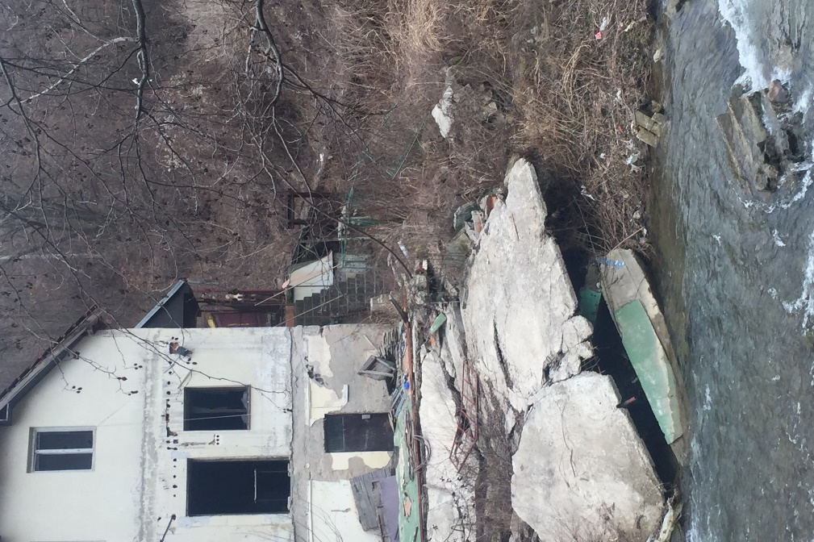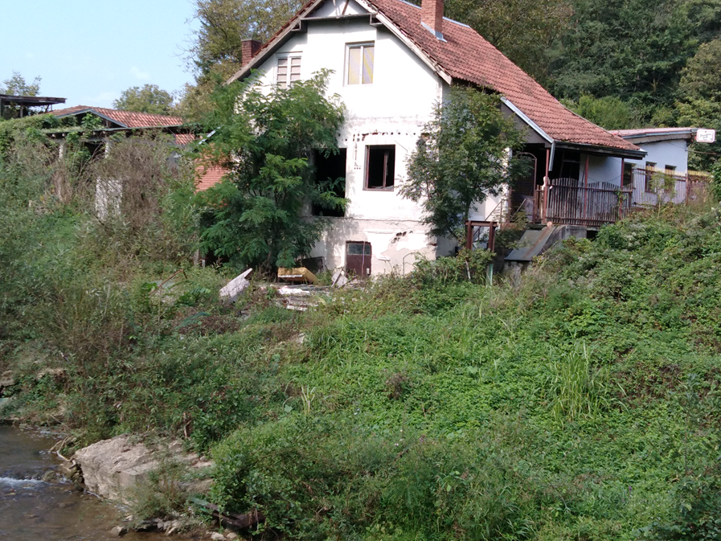
Further figures show typical affected areas and the sub-project location with all of the impacted parcels.

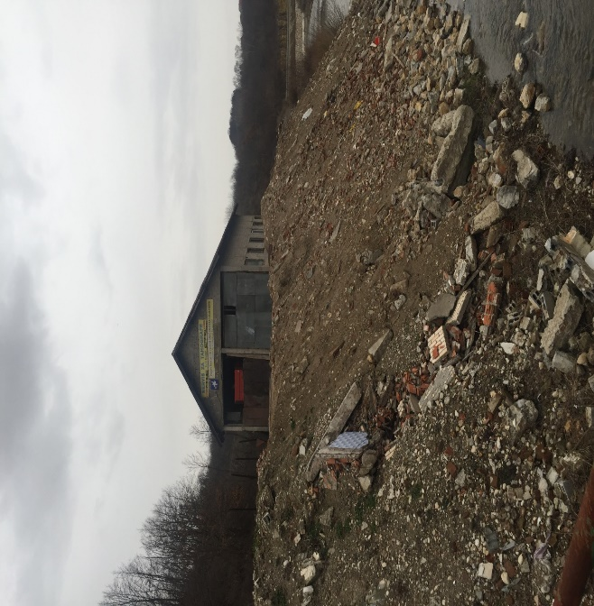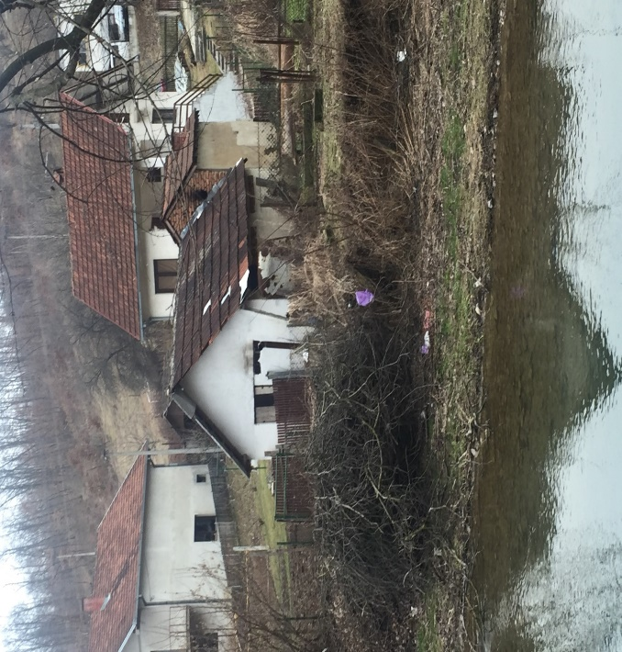
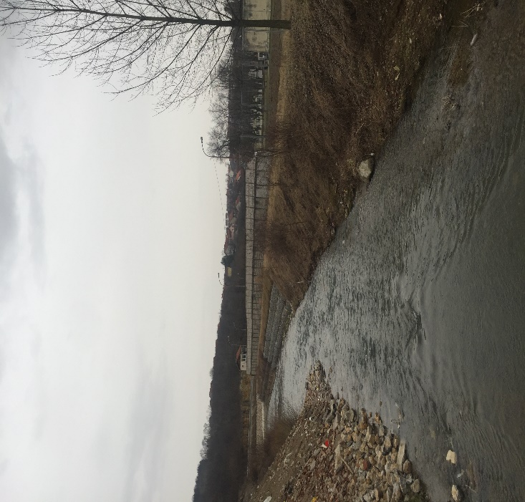
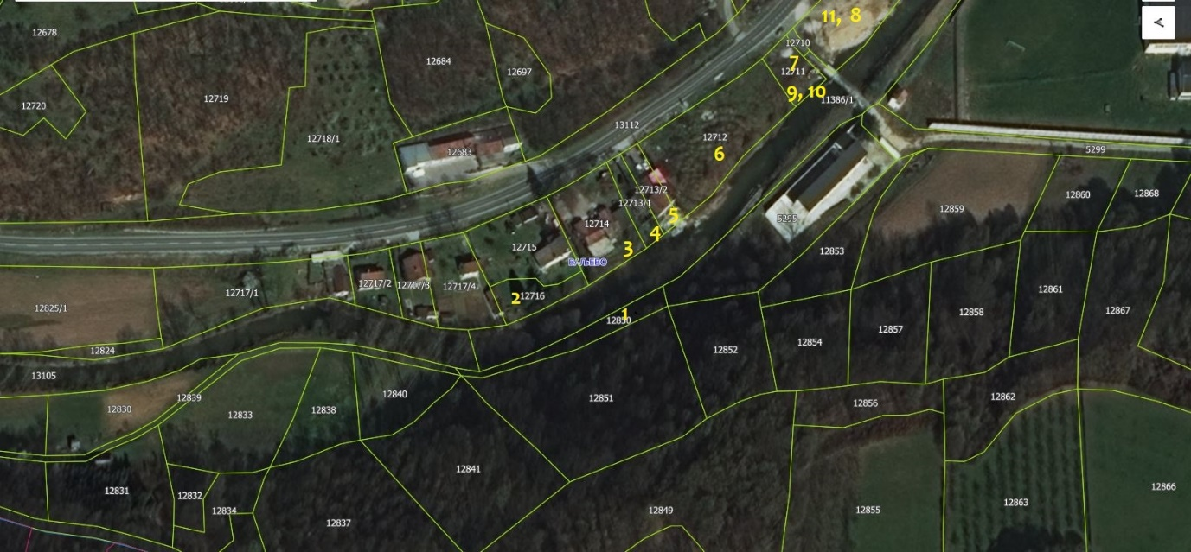
The tables below provide details on the numbers of land plots by type of ownership.
Table 2: Overview of affected land plots by type of ownership and area
Ownership/co-ownership | Number of land plots affected by expropriation | Area m²
Private | 11 | 3339
Public | 4 | 2001
Total | 15 | 5340

Table 3: Data on PAPs affected by expropriation
PAPs | Affected by permanent land acquisition
Total number of private owners | 13
Total number of land parcels | 11
Number of land parcels with private co-owners | 6

The disaggregation of inventory of owners under both impacts revealed that 4 owners are women and 9 are men. By further disaggregation and analysis of records it has been concluded that majority of women gained ownership by exercising their hereditary rights.

Table 4: Overview of Affected Land Plots disaggregated by gender under impact
Ownership | Number of owners (including co-owners) | Percentage  (%)
Women | 4 | 30,7
Men | 9 | 69,3
Total | 13 | 100%

Table 5: Overview on land size patterns (per parcel)
 | m²
Total area impacted by expropriation | 5340
Average area | 303.5
Smallest area | 20
Largest area | 1610

Even in cases where more than 20 percentage of land is affected (not from the entire land holdings but from individual plots) the loss of affected land, does not adversely affect the livelihoods or streams of livelihoods of the affected households as the land owners draw livelihood from employment/pension generated income from non-agricultural activities and the very small scaled production present was entirely subsistence.

Table 6 Overview of type of land type patterns
Type of land affected | No of plots and %
Pasture | 8 (72,72)
Gardens | 1 (12,5)
Other | 2 (25,0)
Total | 11 (100,0)
Source: Valjevo Cadastre office

5.2 Census/Inventory

The Census taken from July 19, 2018 through August 24, 2018 /Inventory of all PAPs and asset survey was developed in order to gather and analyse data and information required to identify all categories of impacts, the Project Affected People (PAPs) directly affected by land acquisition (owners of affected land plots) and loss of assets caused by sovereignty to be exercised over occupied public land.
The Census contains data on the following:
(i) Location and Cadastral Municipality,
(ii) Land plot number,
(iii) Type of impact,
(iv) Name of PAP (owner or user),
(v) Total area of land owned (m²).
(vi) Total area of land to be affected (m²)
(vii) Type of asset on land affected.
(viii) Compensation received or assessed
(ix) Other information relevant for individual cases.

The summarized version of the census database is provided in Annex 4 of this ARAP. And the detailed excel file is accompanying this document as a separate file.

5.2 Socio-economic Survey

The Socio-economic survey was conducted with the support of the City of Valjevo. For purposes of the Survey, during different stakeholder engagement stages PAPs were provided with information that such a survey is planned, and details on the content and information about privacy and protection of personal data presented. All persons affected were invited personally to participate but only 5 out of 13 PAPs accepted to share the relevant socio-economic details of the household affected.
The summary of the key data provided in Annex 3 to this ARAP (the full database is in the form of a separate Excel document). Confidential information about individual persons and properties will not be publicly disclosed.

5.4 Socio-economic assessment of the PAPs

In addition to basic demographic data (age, sex, family size), social and economic information (ethnicity, health, education, occupation, income sources) were gathered from among the affected people. This information provides the implementation authorities with a general understanding of the communities affected by the project, and the scope of compensation and resettlement assistance necessary to mitigate adverse effects.
Particular attention will be given to vulnerable groups living in the Project Area. These groups may include households headed by women or children, people with disabilities, elders and the extremely poor.
The Socio-Economic Surveys were undertaken after all assets and crop surveys were completed. These surveys gathered detailed information at a household and individual level on current living standards, incomes and livelihoods. The objectives of the Socio-Economic Surveys were to identify potential adverse impacts on PAPs and potentially vulnerable people and households; and to serve as a baseline to measure effectiveness of resettlement plans and mitigation measures.
The detailed Socio-Economic Surveys covered the following main topics:
• Demographic Information
• Household Composition
• Education & Skills Base
• Economic Activities & Livelihoods
• Household Incomes
• Health & Welfare
It provides baseline data for future monitoring and evaluation of ARAP implementation.

5.4.1 Owners
Out of a total of 13 owners, 5 accepted to be surveyed which represents 38% of the universe of affected owners.

5.4.2 Demographic features of households

Amongst the interviewed there is 1 single headed, there are two three headed and two five headed households. Further analysis showed that usually two generations live together. Household features are presented below.

Figure 5: Demographic features of households

5.4.3 Gender of Respondents

All respondents were men. Although among the universe of PAPs there is a share of 4 of female but none of them participated in the survey. The title to assets was mostly acquired by exercising the hereditary right. The Law on succession grants equal rights to succession of both male and female successors. These figures should be interpreted with support of the provisions of marital and family law whereas the ownership right is deemed to be distributed equally between husband and wife and if formal registration of property is made in name of only one spouse a legal assumption of ownership is made on behalf of both.

5.4.4 Education
The analysis of the respondent’s answers recognized a fairly high education background. 60% of respondents have university education, 20% post-secondary, followed by 20 % of secondary education and none of the respondents left after graduating elementary school and the ability to read and write Serbian and was used as a proxy for literacy levels. The survey results show that the adult literacy rate is 100%.

5.4.5 Sources of Livelihood for the affected person and monthly income

57 % of respondents reported salaries as their main income followed by pensions in a 43% ratio. The respondents did not report any other source of income neither formal nor informal. No income is land based; there is no commercial agricultural production present. One respondent reported subsistence farming. 20% of respondent declared their monthly income to be above 70,000 RSD(equivalent of 593,22 EUR or 671,78 $per month, 14% reported income between 40,000 (338.98EUR or 383,87 $ equivalent) and 70,000 RSD (569 EUR or 636 $ equivalent) 21% of respondents have a monthly income between 10,000 (84,75 EUR or 95,96$ equivalent ) and 40,000 RSD ((338.98EUR or 383,87 equivalent) and 14% income less than 10,000 RSD (84,75 EUR or 95,96$equivalent). The minimum wage in Serbia in February 2019 is set at a net value of 24.848,00 RSD (210,57 EUR or 238,46 $ equivalent) a month per equivalent adult and only one household had incomes below this lowest wage. When asked to self-assess their economic situation and financial status 4 responded to be very satisfied, 1 was neither satisfied nor dissatisfied.

Figure 6: Household income

Employment status

Figure 7: Employment status

5.4.7 Place of Residence

All respondents live in Valjevo.

5.4.8 Vulnerability
The Study identified one person living below the poverty line and one single female headed household. The impacts of the sub-project land acquisition are so small and unrelated to livelihoods. Thus, they do not pose further impoverishment or marginalization threats on the person identified as vulnerable. Indicators on generic vulnerability have been taken into account and ascertained that the specific types of changes imposed by the Project shall not worsen their vulnerability.

5.4.9 Public infrastructure that will be affected
During implementation of the Project no public infrastructure will be affected.

5.4.10 Community Perception of the Project
The community is very devoted to the success of the Project since the floods are very common and patterned occurrences especially impacting those living at the very banks of the river. The damage they suffer and the constant fear during the heavy rains and snow melts has boosted the support of the community of the sub-project. All respondents look forward to successful completion of the project although requesting that the natural environment be kept as undisturbed as possible. They further suggested the flood protection works to use less concrete and more natural materials like stones, gabion walls etc. These suggestions have been taken into consideration to the extent feasible.

6. RESETTLEMENT COMPENSATION STRATEGIES

6.1 Key Principles

The RPF committed key principles which are incorporated into this ARAP. The principles for the impacts identified could be briefly summarized as follows:
- Resettlement and compensation of Project-Affected People will be carried out in compliance with Serbian legislation and World Bank’s Policies and Procedures on involuntary resettlement OP 4.12 were the more stringent requirement will take precedence
- Affected People will be compensated for their losses at replacement cost to allow restoration at pre-displacement level
- The ARAP implementation and outcomes will be monitored and evaluated by the PIU.

6.2 Cut-Off Date

July 19, 2018 as the date of the Census serves as the Cut-off date. Persons who encroach on the area after the cut-off date are not entitled to compensation or any other form of resettlement assistance. Similarly, fixed assets (such as built structures, crops, fruit trees, and woodlots) constructed after the cut-off date will not be compensated. The individual invitation as well as the minutes of meeting is kept by the Property departments and Public Defender’s office.
A Moratorium notice informing the general public of the declaration of cut-off date was presented to the general public in the form of information posters pinned at the Notice Board of the City of Valjevo. This information shall be again disseminated at the public consultations on the draft ARAP.

6.3 Eligibility

The unit of entitlement is any individual eligible to receive compensation or rehabilitation benefits. Determination of unit of entitlement is in lieu with developing and identifying the census and inventory of all assets impacted by the Project to allow full compensation in line with the Entitlement Matrix. All PAPs identified prior to the cut-off date shall be entitled to compensation, according to the compensation principles of the Law on expropriation, Law on fundamental property rights, RPF and OP 4.12 whereas the more stringent in requirements shall prevail.
Project affected persons are defined to include the following categories:
- Project affected persons, with formal title, who lose all or part of their land;
- Project affected persons, with formal title, who have immovable property with or without building permissions on the land to be expropriated;
- Project affected persons with formal title over businesses that are affected by the loss of all or part of the land on which businesses are located
- Project affected persons with formal title over animal husbandries and agricultural processors that are affected by the loss of all or part of the land on which they are based;
- Project affected persons with formal title of tenancy on private or public land;
- Project affected persons with formal title over land that will be needed during construction on a temporary basis;
- Project affected persons without formal title on affected land or businesses but their livelihoods are directly dependent on the affected land or businesses (e.g., those working on affected agricultural land or working in the affected businesses);
- Project affected persons without formal title of ownership or use but who have established usage of public or private land by investing in immovable objects, crops, woods, trees, fruit bearing trees, vineyards, the age of crops, and the time needed to reproduce them; and
- Any affected community facilities will also be reconstructed or necessary support will be provide for their relation to the community loosing access to such common facilities
This sub-project affects following categories of PAPs
- Project affected persons, with formal title, who lose all or part of their land;
- Project affected persons, with formal title, who have immovable property with or without building permissions on the land to be expropriated;
- Project affected persons without formal title of ownership or use but who have established usage of public or private land by investing in immovable objects;

The entitlements for relevant categories of impact and PAPs shall be as per the Entitlement Matrix as adopted in the RPF for the FER Project shown for impact categories relevant for the identified impacts only.

Table 7: Entitlement matrix for impacts identified
I Impact categories | E Entitlement
Partial loss of land for titled owners | - offer of replacement land of equivalent productive value in the area and vicinity of the land being expropriated, together with all transfer/administrative taxes;  - monetary cash compensation based on the assessed fair value including taxes and fees and top-up supplement to the compensation;  - when expropriation is minor, the option of acquiring land through “Direct Purchase” will also be explored, which means that the Beneficiary of Expropriation will negotiate with the landowner to sell voluntarily rather than to go through the process of expropriation.
Fruit bearing plants, vineyards, standing crops and orchards | - Compensation for lost crops or nursery plants at replacement value Compensation equivalent to the cost to raise a replacement vineyard or orchard, including the value of time needed to reproduce replacement vineyard or orchards, and compensation for lost yields till trees reach full productivity

6.4 Valuation

At the valuation stage, the Beneficiary of Expropriation contacts the Taxation Administration for the assessment of fair value for all land. After the valuation, the Beneficiary of Expropriation presents the offer to the project- affected person. At this point, the project-affected person also agrees to transfer access to the land to the Beneficiary of Expropriation for the commencement of works. If the project-affected person does not accept the offer they can apply to the court, following the standard procedures set forth by Serbian law. The ruling of the court also determines who pays the cost of litigation.

6.5 Compensation for expropriated land

Although the Law provides for compensation in kind, payment of cash compensation is appropriate since livelihoods are not land based and the land taken for the project is a small fraction of the affected asset and the residual is economically viable.
By the time the ARAP has been prepared, all compensation agreements have been reached in amicable and negotiated settlements and compensation paid to the affected persons. The works have not yet commenced and will be allowed only once the public disclosure of this ARAP following the public consultations is completed .

7. GRIEVANCE

MANAGEMENT & REDRESS

7.1 Organizational Arrangements for Grievance Management

The RPF has outlined the basic requirements for Grievance commission and management of its activities. After dully consideration, the grievance redress mechanism was tailored slightly different but much more to fit the purpose and mirroring the local needs, customs, habits and expectations of the community.
The Grievance Committee was established on December 25,2018. The establishment decision is presented in Annex 8 Constitution of Grievance Commission
There are several complementary mechanism in place (e.g the Property department of City of Valjevo, The Engineer (Supervisor of works) daily already on Site and the Public Water Management Company “Srbijavode” Belgrade, VPC Valjevo, an official and formal Grievance Committee was established as a forum for grievances and comments and in relation to payment of compensation, temporary impact to any kind of property, damages in relation to execution of the works, giving people better access to project authorities which has proven to be very helpful. Since the small Scope of the Project and relatively small impact, the GC shall be a body of three members. This is deemed to be sufficient capacity to deal with grievances. One of the members shall be a representative of PAPs, one is an government official from the City of Valjevo not directly involved in the process of expropriation to ensure full impartiality and one member is a representative of the PIU/DfW. The GC will meet as necessary, depending on the range and nature of grievances.
The GC is responsible for receiving and responding to grievances/comments of the following two groups:
- Persons directly affected by the Project including land acquisition impacts,
- Residents living in the Project area who are interested in and/or affected by the Project works

The GC is supported by the PIU/DfW and the City of Valjevo.
The PIU/DfW in cooperation with the City of Valjevo will ensure that all PAPs are fully informed of the grievance mechanism by communicating the existence of the GC , its function, the contact persons and the procedures to submit a complaint in the affected areas.
In order to do so information on the GC was made available at:
- the notice board and website of City of Valjevo (www.Valjevo.org),
- on the Construction Site in the Camp of the Engineer,

In addition, the PIU/DfW has distributed to all the PAPs during the period between December 2018 and January 2019 a brochure containing information on the role of the GC and the contact information for filing grievances/comments. The Brochure is presented in Annex 4 – Grievance Commission brochure.
To allow easy access to the GC a printout of the grievance recording form will be available at the City of Valjevo and for download on the website of the City of Valjevo and of MAEP. The grievance recording form template is presented in Annex 5 – Grievance registration Form.

7.2 Grievance Procedure

The grievance procedure is designed to be effective, easy, understandable and without costs to the complainant. Any grievance can be brought to the attention of the GC personally or by telephone or in writing by filling in the grievance form (by post, fax or personal delivery to the addresses/numbers given below:
City of Valjevo
Grievance Commission
64 Karađorđeva Street
14000 Valјevo Srbija
Telephone: 014/294-900
Fax: 014-/294-921
Email: info@valjevo.rs

All grievances will be recorded in the Grievance Log register and assigned with a number, and acknowledged within 3 working days. The Grievance Log register will have all necessary elements to disaggregate the grievance by gender of the person logging it as well as by type of grievance. Each grievance will be recorded in the register with the following information:
- description of grievance,
- date of receipt acknowledgement returned to the complainant,
- description of actions taken (investigation, corrective measures), and
- date of resolution and closure / provision of feedback to the complainant.
The GC will make all reasonable efforts to address the complaint upon the acknowledgement of grievance. If the grievance/complaint is vague and not clear enough, the GC is obliged to help and provide counsel and even help in redrafting the submission, in order for the grievance/complaint to become clear, for purposes of an informed decision by the GC, in the best interests of persons affected by the Project. If the GC is not able to address the issues raised by immediate corrective action, a long-term corrective action will be identified. The decision of the GC shall give a clear assessment on the grievance/complaint, clear ruling and recommendations for fair remedy and propose measures to modify future conduct that caused the grievance as well as proposed measures to compensate if mitigation measures cannot remedy the harm or injury. The decision shall be in writing and shall be delivered to the person who filed the grievance as well as to any other person or entity to which the recommendation and measures shall apply or is under obligation by Law. The person who filed the grievance can express his/her personal satisfaction to the outcome of the grievance resolution procedure.
The complainant will be informed about the proposed corrective action and follow-up of corrective action within 7 working days upon the acknowledgement of grievance.
Figure 8: Grievance Flowchart/ feedback value chain
DAYS | ACTIONS
0 | Receive Grievance
3 | Acknowledge Receipt
5 | Assess and Assign
10 | Investigate and discuss with Claimant
20 | Decide and inform Claimant
30 | Follow up and verify implementation of resolution
32 | Close out
At any time | Access to judicial procedures if final agreement cannot be reached amicably

If the grievance cannot be addressed or if action is not required, a detailed explanation/ justification will be provided to the complainant on why the issue was not addressed. The response will also contain an explanation on how the person/ organization that raised the complaint can proceed with the grievance in case the outcome is not satisfactory.
At all times, complainants may seek other legal remedies in accordance with the legal framework of Republic of Serbia at any time. None of the legal remedies interferes with the other nor prevents any person from perusing their request.
The GC will publish, and provide the GC with copies, one intermediate report on the number and type of grievances received, comments addressed and closed-out, disaggregated by gender and type of grievances/comments two months after establishment, another intermediate report during construction works and one final report after completion of works. No Grievances were received by the GRM since its establishment on December 25,2018.

8. Consultation and Participation
The Project Implementation Unit (PIU), together with the representatives of Municipal departments in charge of expropriation, is responsible for communicating necessary project and process information, as discussed in the ARAP, to affected communities, Project Affected People (PAPs) and representatives of Local Community Offices. The PIU is assisting the city officials in understanding the requirements set out in the RPF and ARAP This is not a one-off action. The PIU will provide ongoing support until full implementation is achieved.
The PIU, together with the City of Valjevo, the PWC and the external Social Safeguard consultant will carry out public consultations on the ARAP and information dissemination reflecting main issues of relevance to the Project. Immediately before the commencement of civil works, all stakeholders will be timely informed about the Project’s scope and contacts for further information inquiries, the available grievance mechanism and the disclosure of the publicly available Project documents through:
- announcements in the local daily media,
- the website of www.Valjevo.org
- noticeboard of City of Valjevo
This ARAP will be disclosed in Serbian, and English on the above-mentioned websites, as well as made available as printed copies at the premises of City of Valjevo and the premises of the PIU.

Outcome of public consultation

9. Institutional arrangement and Implementation Team

9.1 Responsibility for Implementation

Implementation of the Abbreviated Resettlement Action Plan is the responsibility of the the Project Implementation Unit (PIU) of the Directorate for Water Management. The PIU will monitor the overall implementation of the subproject, cooperate with Vršac Municipality, the Contractor to be elected for construction works. Other organizations and parties involved in the process of expropriation are the Ministry of Finance, Tax Administration, and accredited experts.
The table below provides an overview of the responsibilities and arrangements for implementing the requirements of this ARAP.

Table 8: Organizational Responsibilities and Arrangements
Task | Responsible Entity
Disclosure of information and documents to all Project Affected People and communities, | PIU/ City of Valjevo
Keeping records of consultation activities | PIU
Direct communication with and, if needed, visits to owners and occupants | PIU/City of Vršac
Valuation of property to be acquired | City of Vršac with Tax administration office and Accredited experts
Monitoring and reporting with respect to land acquisition | PIU
Monitoring and reporting with respect to temporary land occupation carried out during construction | PIU/ Supervising Consultant& Contractor
Grievance management | PIU/GC/Contractor
Completion Report | PIU/Resettlement consultant
.

9.2 Institutional Capacities

The implementation of the provisions and obligations under this ARAP are with the Ministry of Agriculture which assigned responsibility for implementation of FERP Sub-Component 3 to the DWM. The DWM already has an established PIU for a World Bank financed Irrigation and Drainage Rehabilitation Project which closed on March 31, 2013. During preparation of investments and implementation of works, the PIU is working in close coordination with the relevant PWMCs, as well as with the City of Valjevo.
The staff assigned for implementation of this ARAP and the Valjevo Flood protection sub-project is deemed to be sufficient to carry out all tasks related to ARAP implementation. However, the PIU has engaged an external short-term expert to support the implementation and assist in the completion report.
The organization of the PIU is presented in the hierarchy chart below:

Figure 9: Organization of PIU

10. Implementation Schedule

Table 10: Tentative Implementation Schedule for ARAP Valjevo
N° | Activity | Responsibility | Timing
 | Census and socioeconomic baseline data necessary to establish baseline conditions and formulate entitlements | PIU/Social Safeguards Specialist | Census completed on July 19, 2018  Socioeconomic baseline completed during December 2018 and January 2019
 | Valuation at negotiation stage | Tax administration office | Completed in August 2018
 | Constitution of GRM | PIU /City of Valjevo | Completed on December 25, 2018
 | Payment of Compensation | Municiaplity of Valjevo | Completed during December 2018 and January 2019
- 5 | Disclosure of draft ARAP | PIU | Planned for March 17, 2019
 | Public consultative meeting | PIU/City of Valjevo | Planed for March 27, 2019
 | Disclosure of final ARAP | PIU/City of Valjevo | Planend for April 1, 2019
 | Payment of Taxes in cases of acquisition of new land | Municipality of Valjevo | If needed but not later then November 2019
 | Completion Report | PIU | Planned for December 15, 2019

11. Monitoring, Evaluation and Reporting

Monitoring of the land acquisition and resettlement process will be conducted by the PIU to:
ascertain whether activities are in progress as per schedule and the timelines are being met;
assess whether the compensation / rehabilitation measures are sufficient;
identify any potential issues (including monitoring of grievance management in terms of recording and responding to grievances within the specified timeframe); and
Identify methods to mitigate any identified issues.
In addition, the construction work supervision consultant will have a duty and obligation to monitor implementation of social requirements during the construction phase. The following shall be their duties:
Supervision of the contractors in performance of their obligations in respect to ARAP timeline
Preparation and submission to the MoAEP of regular reports on implementation of measures for social monitoring;
Provision of service to the local community through receipt of feedback and proposals.
The Construction notice board on the construction site will include clearly visible information on contact persons on behalf of the supervision, as well as working hours for contacts with the public. All complaints, praises, proposals received by the supervision contractor, would be forwarded together with the Supervisor’s opinion to the Employer for further acting. The idea is that every reaction of the local population is provided with a timely response, while a unified record of the correspondence with the local population will be presented in regular reports to the financing institution; It is very important that local - The population shall be fully aware of complaint possibility and that mechanism for submission of complaints is very simple.
Suspension of works causing a high level of noise in periods when such noise is not allowed;
Suspension of the works if inadequate protection of local population and environment against dust and pollution is provided. It is planned that within the final phases of the works execution, the supervisor completes questionnaires with the local population on behalf of the Employer in order to assess the level of content of local population. The questionnaires would be sent to the mailboxes of locals, while ones completing these questionnaires could deliver them in person to the supervisor’s representative or send them by regular post to the Employer’s address. Experience gained during the realization of the different infrastructure rehabilitation projects in Serbia, funded by WB Loans, significantly contributed to preparation of bases for social monitoring and assessment subsequent mitigation of impacts produced by the project on local community. Related to positive practice, PIU representative will perform regular controls of measures taken by the contractor and supervision, and control will be performed by the checklist shown in Annex 6 Social screening check list.
The PIU will maintain a land acquisition database on the owners/users of properties that have been affected. The data/information will be updated periodically in order to keep track of the progress of such owners/user.
The PIU shall keep a monthly updated status on all baseline information.
Hereby indicators to be used for monitoring of implementation of this ARAP are designed and shall include inter alia:
- Overall spending on expropriation and compensation
- Number of PAPs by categories and number of project affected households by categories
- Number of PAPs whose property has been damaged by construction works
- Number of PAPs compensated for damages
- Number of public meetings and consultations with affected people
- Number of m2 expropriated,
- Number and percentage of individual compensation agreements signed before the beginning of construction activities,
- Number and type of grievances received by the GC related to land acquisition (number of grievances submitted, number and percentage of grievances resolved within the specified timeframe of 7 days, number and percentage of people satisfied with the outcome, i.e. the response provided to their grievances/comments, all disaggregated by gender of complainant), and number of legal actions initiated in relation to land acquisition)
- Number of grievances received by the GC related to construction works
- Number of engaged local workmanship for the purpose of the works execution
(person-month and number of actually employed persons disaggregated by gender);
- Number of contracts concluded by the contractor in local community (e.g. for accommodation of workers, lease of lots for storage of materials, etc.)

The PIU shall keep Monthly updated database in the form of excel spreadsheets and send semi-annual updates to the World Bank.

10.2 Completion Report

The Beneficiary of Expropriation (DfW/PIU) will monitor the implementation of the expropriation processes, both through internal, official institutional arrangements, as well as by the independent, external consultant, which has been appointed by implementing entity. The external monitoring and evaluation consultant is on board and will report to the PIU and the WB on a monthly basis as per agreed monitoring progress template report.
Based on the monthly reports, the PIU shall do an in –house completion report within 2 months of resettlement completion to summarize the implementation of the ARAP. The report should verify that all physical inputs committed in the ARAP have been delivered and all services provided. In addition, the report should evaluate whether the mitigation actions prescribed in the ARAP have had the desired effect. The socioeconomic status of the affected population should be measured against the baseline conditions of the population before displacement, as established through the census and socioeconomic studies. The internal completion report is considered appropriate in comparison to the extent of impact.

11. Costs and Budget

As per national requirements the costs of the land acquisition is financed by the Beneficiary of expropriation i.e City of Valjevo. The proceeds required for land acquisition were secured and allocated in the Budget of the City of Valjevo. Certificate of Evidence of funds is presented in Annex 10 Evidence of secured funds for expropriation.

Table 11: Assessment of Budget to be paid for Expropriation
Component | # of plots | Area of land in total (m2) | Budget w/ contingency for regsitration fees* made available | Contingency amount for Registration fee (included in Total Budget) | Type of cost per category of land/structre | Costs estimation  As Per Tax administration  (RSD) (EUR) |  |  | Status of payment
Component 3:  Land acquisition by exprorpiation | 11 | 3339 | 111.400.000,00 RSD | 130.000,00  RSD  1.101,69 EUR | Pasture 2nd class | 4.302.778,00 | 36.464,22 | P A I D DURING DECEMBER 2018 AND JANUARY 2019
 |  |  |  |  | gardens | 227.720,00 | 1929,83
Crops and fruitbearing trees |  |  | 111.400.000,00 RSD |  | Replacement cost for loss + yield | 55.612,00 | 471,28 | P A I D DURING DECEMBER 2018 AND JANUARY 2019
TOTAL: | 11 | 3339 |  | 130.000,00 |  | 4.586.110,00 | 38.864,33

Annex 1 – Invitation to Public Consultation on ARAP Draft
In accordance with the WB Operational Policy (OP 4.12)

The Ministry of Ministry of Agriculture and Environmental
Protection
Directorate for Water Management. issues an invitation for

PUBLIC CONSULTATIONS

on
ABBREVIATED RESETTLEMENT ACTION PLAN FOR (ARAP)
For Valjevo Flood Protection sub-project
Under the Serbia Floods Emergency and Recovery Project (FERP)
To be held on XXXXXXXXXXX, 2019 at XXPM (Local time ) at the City of Valjevo
The document subject to the consultation is made available in hard copies at the the following adresses:
- At the premises of The Ministry of Ministry of Agriculture and Environmental Protection Directorate for Water Management, Belgrade, on the second floor, on working days from 11:00 AM to 01:00 PM (local time), within 14 days in regards to the date of public announcement of this invitation.
- the premises of City of Valjevo, during working hours,
- on the web site of the Ministry of Agriculture and Environmental Protection Directorate for Water Management: www.rdvode.gov.rs
- On the website of the City of Valjevo: www.Valjevo.org

Questions and concerns in respect to the provisions of the documents can be submitted in writing to the following address below as well as by e-mail and be submitted and stated directly during the consultation.

If you need any additional information, please contact:

Floods Emergency and Recovery Project (FERP)
Dr Ivana Ribara 149/11, Street
11000 Belgrade, Serbia
Tel: +381-(0)11-6163-600

Annex 2 – Socio-economic Survey Questionnaire

Questionnaire number

Survey date: .2016

City: Valjevo
Location:
Address:
Cadastral plot reference:
Whole plot affected: YES / NO
If no, specify the size of the non-affected part: m²

1. GENERAL INFORMATION ON THE RESPONDENT
1.1. Respondent’s name and surname:
1.2. Place of living:
1.3. Owner or user of land plot:
1.4. Ethnic group:
1.5. Phone number:

2. GENERAL INFORMATION ON AFFECTED PROPERTY (PLOT)

2.1. Location of the plots, total number per location and cadastral reference
Location | Total number of plots | Cadastral plot reference | Current use  Tick applicable use
1. |  |  | Arable land  Forest  Pasture  Unused
2. |  |  | Arable land  Forest  Pasture  Unused
3. |  |  | Arable land  Forest  Pasture  Unused

3. OWNERSHIP ISSUES

3.1. Owner: Yes No

3.2. User: Yes No

3.3. Ownership details
With fully registered title
Legalization in progress |  | What stage is the legalization process in:
Formal lease of public property |  | Owner
Formal lease of private property |  | Owner (contact details):
Informal lease |  | Owner (contact details):
Fully informal |  | How did the owner take possession of the above mentioned plot?
Shared ownership  YES / NO |  | If yes, name other co-owners:
Tick applicable box

4. AGRICULTURAL ACTIVITIES

4.1. Perennial / annual species: ____________________________________________________________________________
4.2. If perennial: Year of plantation: ____________

4.3. Average yield on this plot according to farmer :_____________________________________________ (specify measurement unit).

4.4. Overall land holdings of the farmer, including this plot and all others: ____________________ hectares

Including farm lands, pastures, forests, arid and unused land – Include all land available to the farmer regardless of ownership.

4.5. Of which farmed this year: ______________________ hectares
5. AGRICULTURAL ACTIVITIES

5.1. Do you sell crops ____________________________________________________________________________________

5.2. If yes, what is your average annual income generated by selling crops:________________________________________

5.3. Do you use crops to meet your own needs (consumption): __________________________________________________

5.4. Did you have any plans with affected part of the land plot? YES / NO

5.5. If yes, what would you like to do with affected part of the land plot ?__________________________________________

6. GENERAL INFORMATION ON AFFECTED HOUSEHOLD MEMBERS

6.1. Information on household members
 | Name and surname | Relationship with Head of Household | Year of Birth | Gender |  | Occupation | Education  (degree of vocational education)
1 | HH | HH |  | M | F
2 |  |  |  | M | F
3 |  |  |  | M | F
4 |  |  |  | M | F
5 |  |  |  | M | F

7. SOCIO-ECONOMIC DETAILS ABOUT THE AFFECTED HOUSEHOLD

VULNERABILITY
7.1 Is any of the household members suffering from one of the following problems: |  | 7.2. Social benefits (yes or no, if yes which kind of assistance)
Physical handicap
Mental handicap
Chronic disease requiring regular medical attention
Chronic disease requiring hospitalization
unemployed or without regular income
Elderly and/or elderly and single
Member of ethnic minority (e.g. Roma)
Other problem (specify)
Indicate the number of affected household members in section 2 in the relevant table

7.1. Total household income

Which of the following categories does the average total monthly income of your whole household fall in: |  |  | Amongst the following, what are your main sources of income:
Less than 10, 000 RSD |  |  | Salaries |  | Pensions
Between 10.000 and 40, 000RSD |  |  | Personal agricultural production |  | Government or other assistance
Between 40,000 and 70,000 RSD |  |  | Small business |  | Other (specify):
More than 70,000 RSD |  |  | Remittances |  | Other (specify):
In case there are several household members earning the income, please consolidate them together |  |  | Tick appropriate box

7.2 Total Monthly expenditure and categories
Which of the following categories does the average total monthly spending’s of your whole household fall in: |  |  | Amongst the following, what are your main expenditure categories or assign a relevant range or amount
Less than 10, 000 RSD |  |  | Food and non-alcoholic beverages
Between 10.000 and 40, 000RSD |  |  | Housing related expenses (rent, water, electricity, gas, fuels, etc.)
Between 40,000 and 70,000 RSD |  |  | Food
More than 70,000 RSD |  |  | Furniture, household equipment and routine maintenance of the house
 |  |  | Health
 |  |  | Education
 |  |  | Leisure and recreation
In case there are several household members earning the income, please consolidate them together |  |  | Tick appropriate box

7.2. Are you satisfied with your economic situation?
Highly satisfied
Satisfied
Neither satisfied nor dissatisfied
Dissatisfied
Highly dissatisfied
Tick applicable box
Anything you wish to add not covered? -----------------------------------------------------------------

THANK YOU!

Annex 3 – Summary of Socio-economic Data for those expropriated
Note: this summary table shall not be subject to public disclosure due to personal information protected under the law
Cadastral parcel n⁰ | Cadastral municipality |  | PAP's ID N⁰ | Parcel area affected (m²) | Percentage (%) of land affected | trees and plants | Compensation for land  RSD | Status of payment
12850 | Valjevo |  | 1 | 365 | 65.2 | 18.600,00 | 500.780,00 | Paid
12716 | Valjevo |  | 2,3 | 139 | 28.5 | 18.506,00+  18.506,00 | 95.354,00+  95.354,00 | Paid
12714 | Valjevo |  | 4,5,6 | 139 | 18.1 | N/A | 190.708,00 | Paid
12713/1 | Valjevo |  | 4,5,6 | 62 | 11.2 | N/A | 85.064,00 | Paid
12713/2 | Valjevo |  | 7 | 65 | 17.4 | N/A | 89.180,00 | Paid
12712/2 | Valjevo |  | 8,9,10 | 526 | 100 | N/A | 240.557,00+  240.557,00+  240.557,00 | Paid
12711/2 | Valjevo |  | 11,12,13 | 183 | 44.3 | 1.559,00 | 2.802.996,00 | Paid
12711/3 | Valjevo |  | 11,12,13 | 56 | 13.6 | 1.559,00 | 2.802.996,00 | Paid
12709/2 | Valjevo |  | 11,12,13 | 1610 | 42.1 | 1.559,00 | 2.802.996,00 | Paid
12709/3 | Valjevo |  | 11,12,13 | 20 | 47.2 | 1.559,00 | 2.802.996,00 | Paid
12711/1 | Valjevo |  | 11,12,13 | 174 | 0.60 | 1.559,00 | 2.802.996,00
 |  | Total compensation for land and assets in RSD |  |  |  |  | 4.561.441,00 | paid
 |  | Total compensation for land and crops in EUR (based on ARAP exchange rate) |  |  |  |  | 38.656,28 | paid

Annex 4 – Grievance Commission brochure
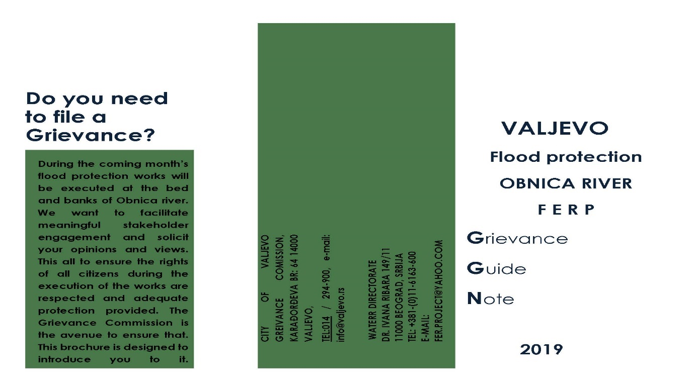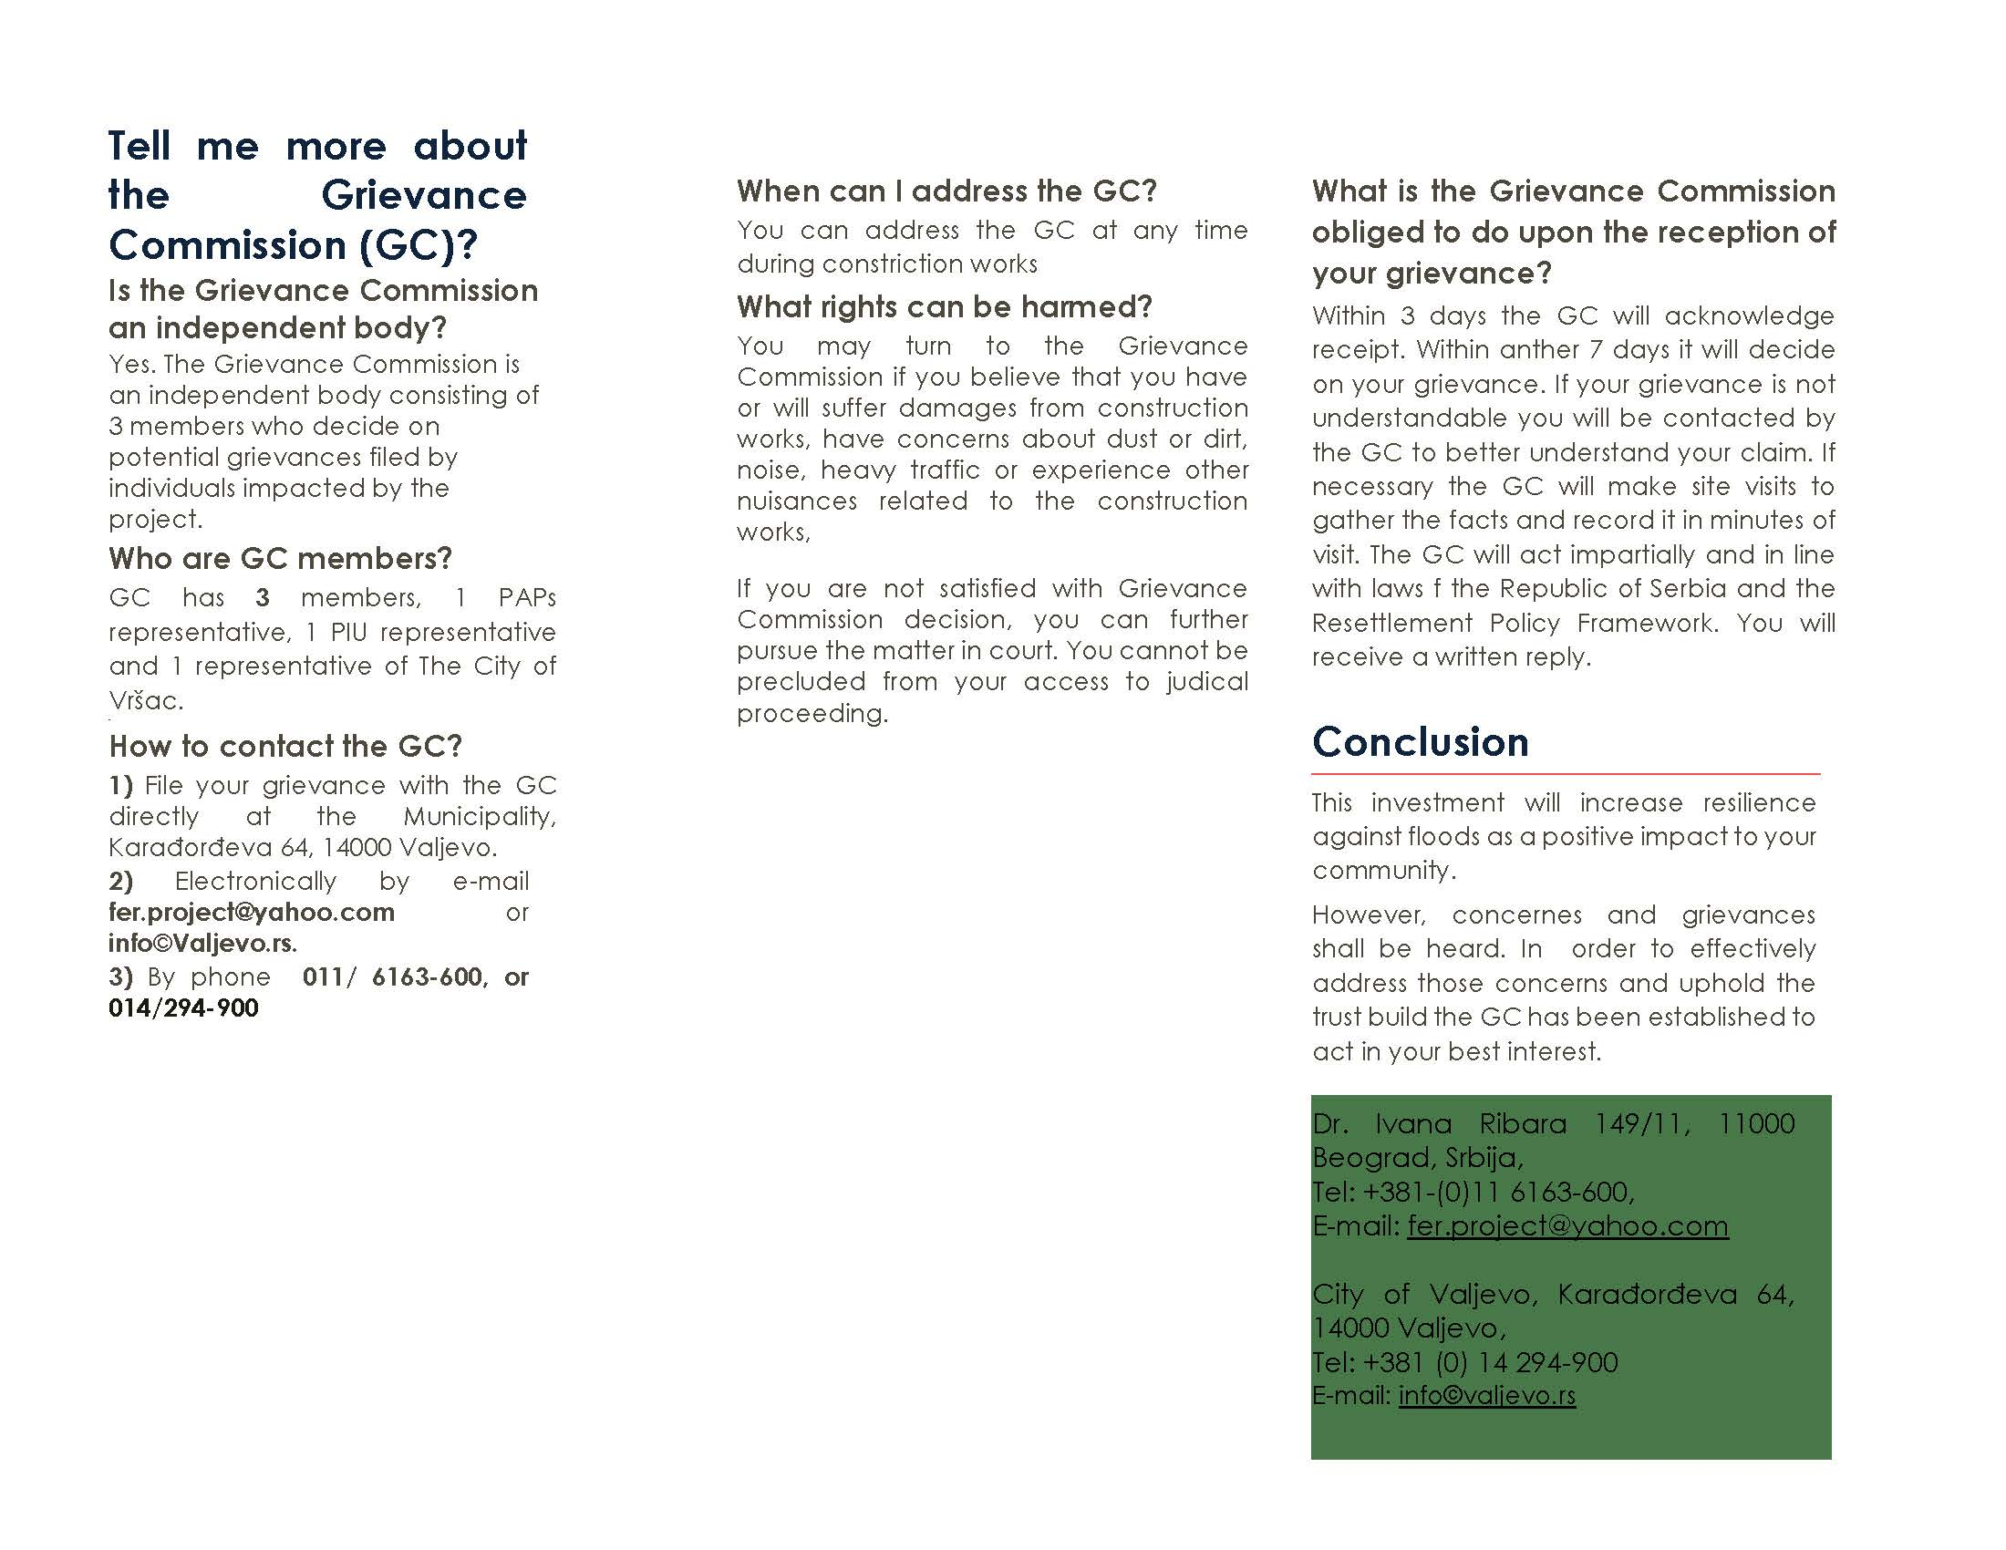

SERBIA FLOODS EMERGENCY AND RECOVERY PROJECT (FERP)
Component 3- Valjevo sub-project
Reference number:
Full name:
Contact information:

Please mark how you wish to be contacted (mail, telephone, e-mail).
- By post: Please provide mailing address:
__________________________________________________________________________________
__________________________________________________________________________________
- By telephone: ___________________________________________________
- By e-mail: ___________________________________________________

Description of the event giving rise to the grievance. What happened? Where did it happen? Who did it happen to? When did it happen? Main consequences of the event? Any other relevant information on the grievance

How do you see your case would be best resolved?

Date and Place| Signature

Annex 6- Social screening check list

 | SUB-PROJECT: |  | (section name)
 | Screening team: |  | (Names of team members performing screening)
 | Attachments: |  | (Photos, additional docs, tables, etc.) |  |  | date:
No |  | Item description |  | Checked | Note for designer |  | Screening comments
1 |  | Identification of section location  Start point  End point
2 |  | Identification of lane width  Lane width  Lane no:
3 |  | Shoulders width  Shoulders width  Shoulders condition
4 |  | Identification of Settlements, and subsections with high intensity pedestrian traffic  Settlements  Type of settlements  High intensity pedestrian traffic
5 |  | Identification of subsections with agricultural land next to the flood protection structure  - Agricultural area identification
6 |  | Identification of subsections passing by the woods  Woods  Green areas
7 |  | Identification of structures  Commercial objects (workshops, cafes, stores etc.)  Residential objects
8 |  | Identification of places of great cultural heritage  Historical heritage  Cultural heritage  Nature preserved area  Weekend rest areas
11 |  | Vulnerable categories needs  Access to road  Sidewalks  Cycle lane  Banquette  Underground passage
12 |  | Identification of rivers  - Sources of drinking water
13 |  | Identification of utilities  Electricity  Low-voltage cable  Overhead Installation
15 |  | Identification of dangerous places (memorial stones and others)

Annex 7– Individual invitation to Public consultation on draft ARAP to be sent to all PAPs

In accordance with the WB Operational Policy (OP 4.12)

The Ministry of Ministry of Agriculture and Environmental
Protection
Directorate for Water Management
Invites
Mr. XXXXX from Valjevo
to
PUBLIC CONSULTATIONS
on
ABBREVIATED RESETTLEMENT ACTION PLAN FOR (ARAP)
For Valjevo Flood Protection sub-project
Under the Serbia Floods Emergency and Recovery Project (FERP)
To be held on August X, 2018 at XX:XX PM (Local time ) at the City of Valjevo
The document subject to the consultation is made available in hard copies at the the following adresses:
- At the premises of The Ministry of Ministry of Agriculture and Environmental Protection Directorate for Water Management, Belgrade, on the second floor, on working days from 11:00 AM to 01:00 PM (local time), within 14 days in regards to the date of public announcement of this invitation.
- the premises of City of Valjevo, during working hours,
- on the web site of the Ministry of Agriculture and Environmental Protection Directorate for Water Management : www.rdvode.gov.rs
- On the website of the City of Valjevo: www.Valjevo.org

Questions and concerns in respect to the provisions of the documents can be submitted in writing to the following address below as well as by e-mail and be submitted and stated directly during the consultation.

If you need any additional information, please contact:

Ministry of Agriculture and environmental protection
Water Directorate
Dr. Ivana Ribara 149/11
11000 Beograd
Tel:+381 11 6163 600

Annex 5 – Grievance registration Form

Annex 8 - Constitution of Grievance Commission (Original in Serbian)

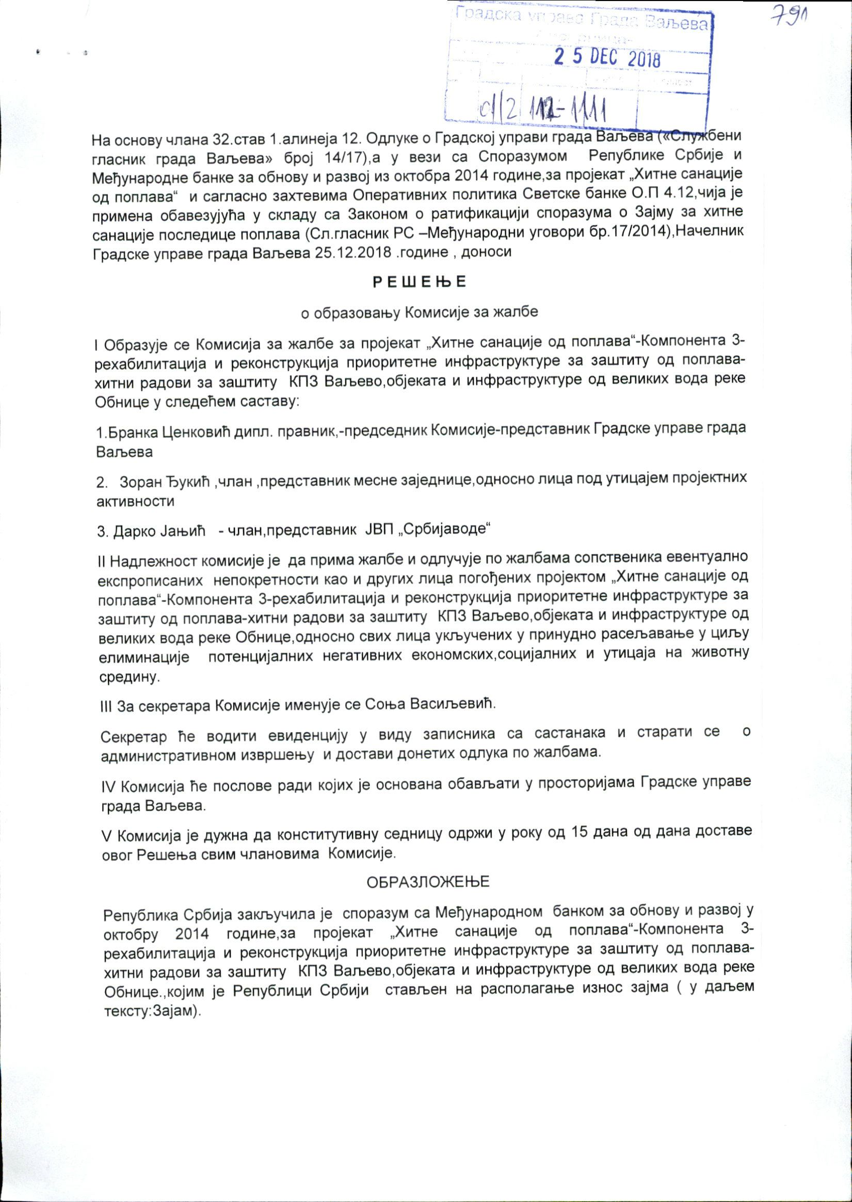
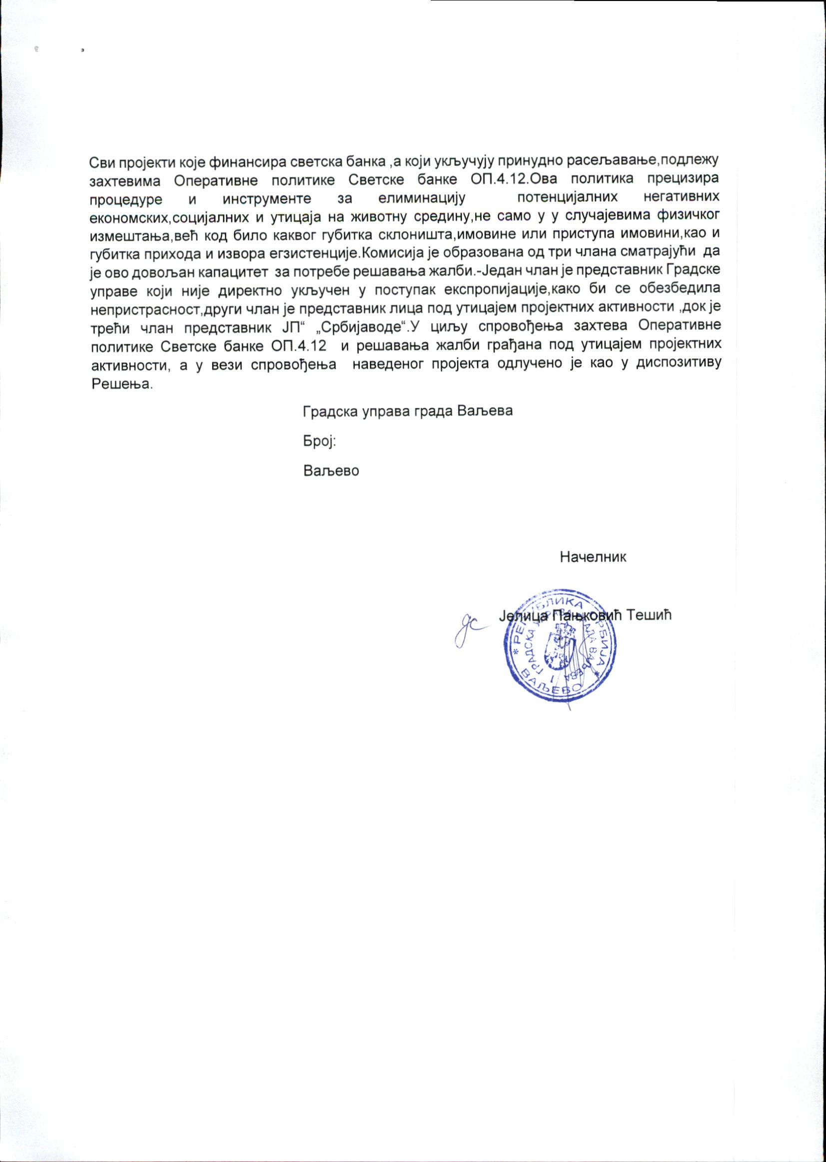

Annex 9 – Decision on Public interest (Serbian)
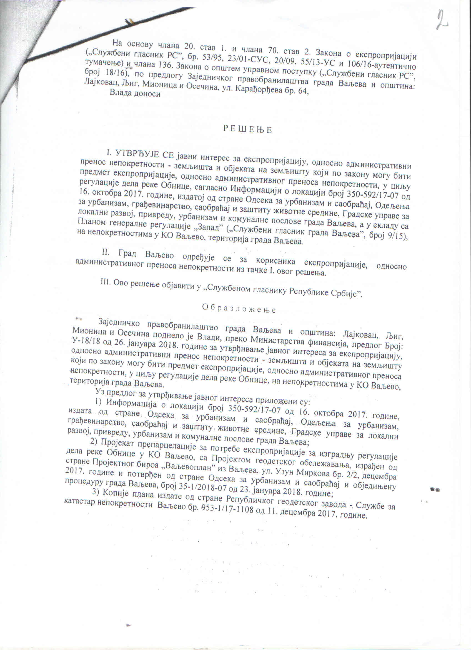
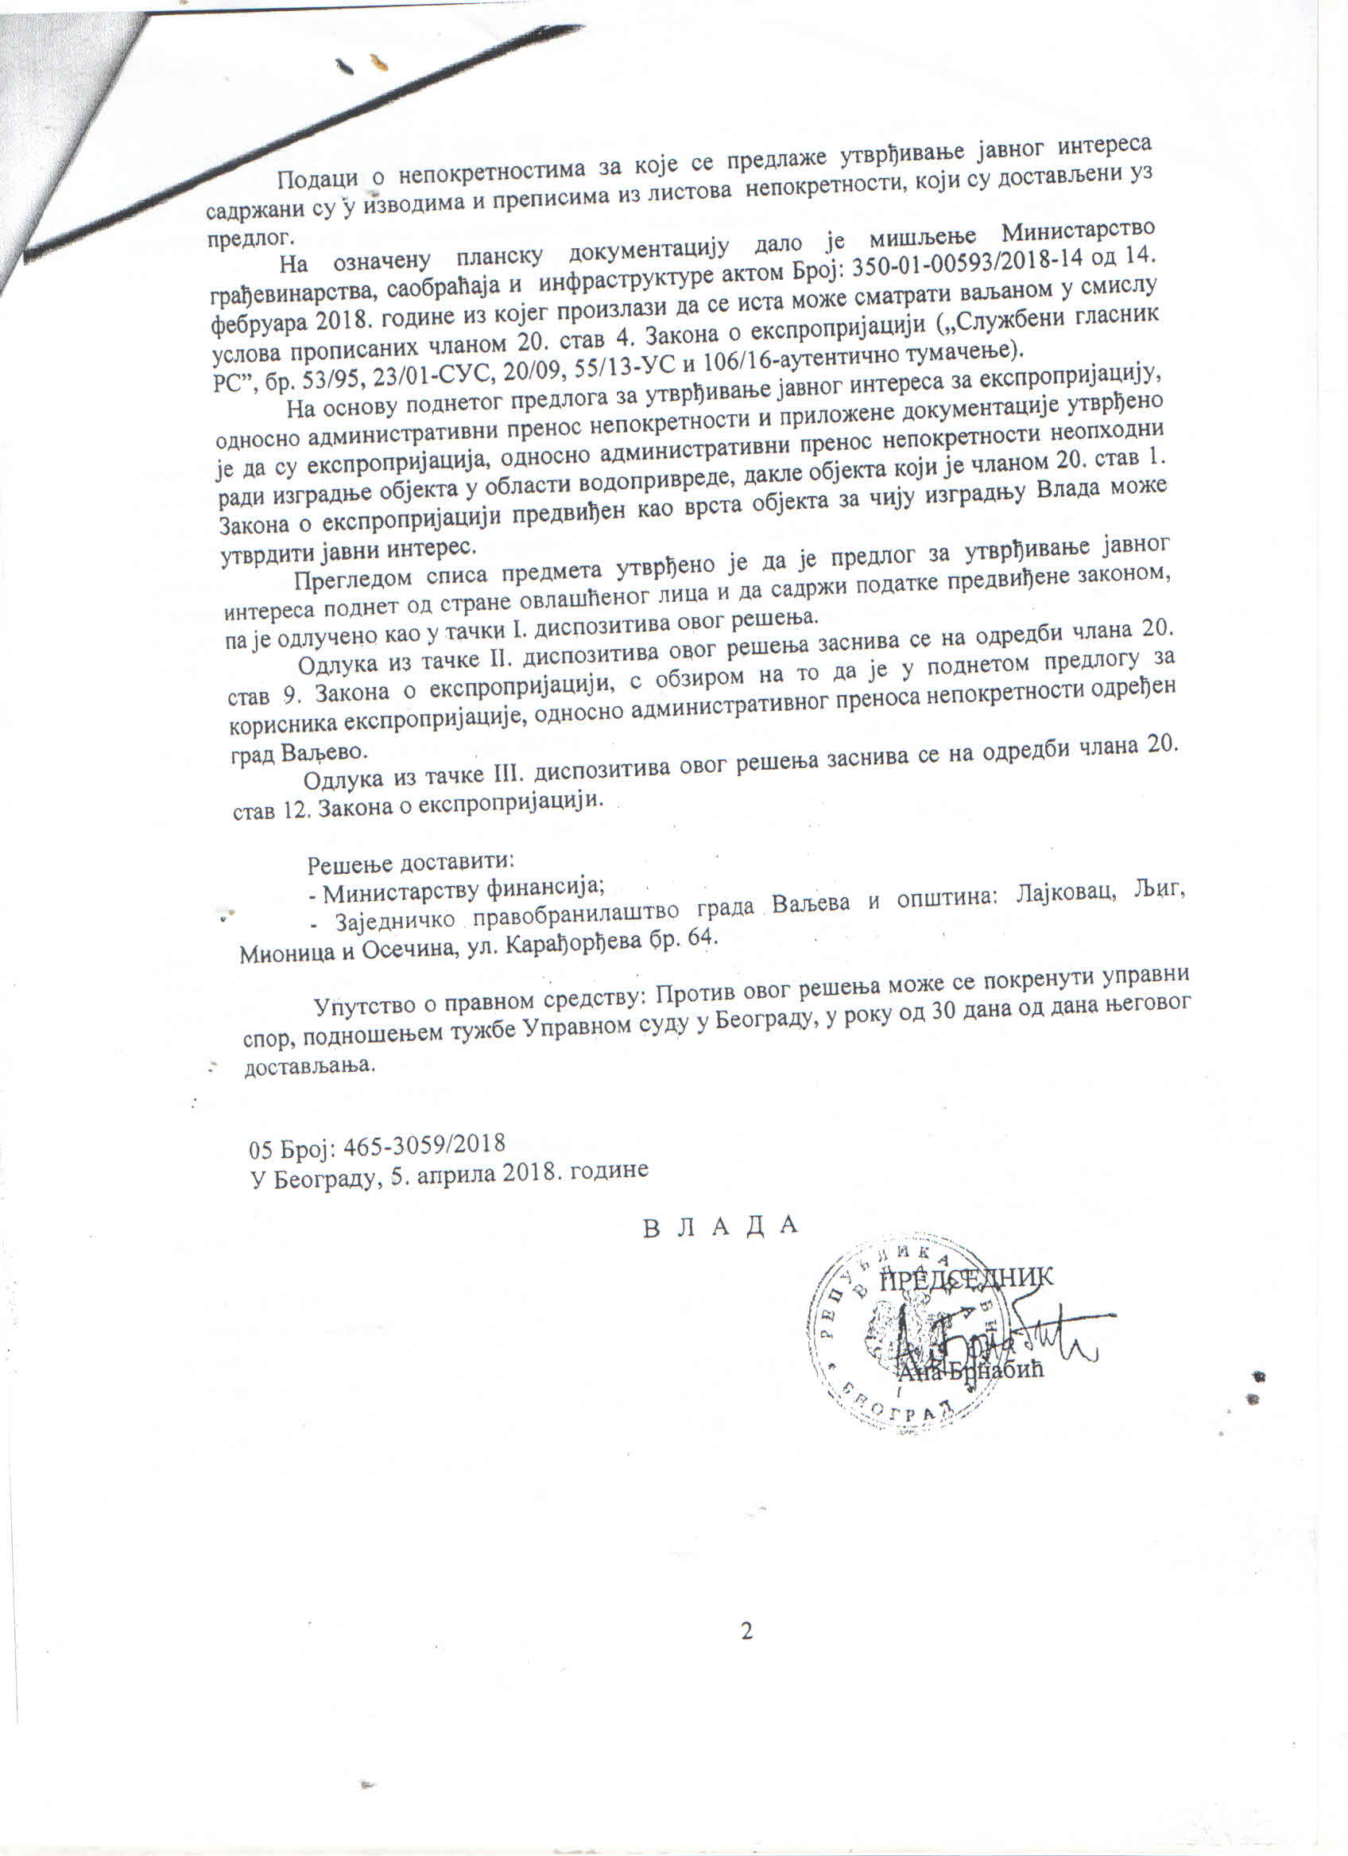

Annex 10- Budget availability confirmation (Serbian)

Unofficial translation
Republic of Serbia
City of Valjevo
City Administration of Valjevo
Finance Department
Number: Off/18-06
Date: October 18, 2018
Valjevo

By virtue of the Decision on the Budget of the City of Valjevo for the fiscal year 2018 (“Official Gazette of the City of Valjevo” No. 14/17) classification 4, heading 1, program 0602, activity 0602-0001, functional classification 130, economic classification 541 – Land acquisition, an amount of 111.400.000, 00 RSD has been earmarked.

Head of the Financial department
Željko Tabašević

__ - - - - - - - -- - - - --- - - - - - - -- - - -End of Translation - - - - - - - - - - - - - - - - - - - - - - - - - - - - - - - - - - -,

Annex 11 – Moratorium notice (translation) – published at the Notice Board in July 2018

Republic of Serbia, Recovery Needs Assessment, 2014 http://www.obnova.gov.rs/uploads/useruploads/Documents/RNA-REPORT-140714.pdf, last accessed on January 29,2018.
Disaster effects are classified under damages and losses. Damage refers to the total or partial destruction of physical assets existing in the affected area and losses refer to changes in economic flows arising from the disaster.
See RPF for FERP, availalble at http://www.rdvode.gov.rs/doc/20170312%20FINAL%20RPF%20SERBIA%20FERP,%20%2040p.pdf accessed on February 19, 2019
See World Bank OP 4.12 http://web.worldbank.org/WBSITE/EXTERNAL/PROJECTS/EXTPOLICIES/EXTOPMANUAL
Law on Budget and the Budget system, http://www.paragraf.rs/propisi/zakon_o_budzetskom_sistemu.html accessed on March 11,2019
The original number of parcels is 8. Parcels have been later divided for purposes of registration in the Cadastre and served as identification of impacts
The classification of land is as registered in the cadastre office and does not necessarily mean this is the way the parcel is utilized
Exchange rate given at beginning of this ARAP on top of page 2
Only part of the Entitlement Matrix relevant for specific impacts identified under this Subcomponent has been presented. For access to full entitlement Matrix within RPF please see RPF for FERP available at http://www.rdvode.gov.rs/, accessed on July 24,2016
Total land holdings were not disclosed by the PAPs. These figures represent % of affected land plots

